Economic inequality is a hot-button issue in contemporary PRC politics. Xi Jinping’ “Common Prosperity” initiative seeks to resolve decades of unequal growth and fix the social issues which have stemmed from it. What drives this new push for redress of economic grievances? To answer this question, we turn to the data and examine our survey research whch seeks to establish basic facts about how Chinese citizens view economic inequality in their own country and in comparison with the United States. Overall, we find that, while Chinese citizens recognize economic inequality in their own country, they are optimistic regarding future trends and feel issues of inequality pose less of a threat to stability than they do in the U.S.

First, let’s discuss factual beliefs about inequality to establish a baseline, a clear set of descriptive statistics which can help us establish what Chinese citizens actually believe about the state of economic inequality. Let’s start with an index of factual evaluations based on responses to four true or false questions. Respondents’ total factual scores are summed over the four questions, giving us a result where the higher the score, the more the respondent overestimates inequality in China. The survey shows that, somewhat surprisingly, a plurality of Chinese people (42%) have an accurate view on income inequality in China. About one-third overestimate the gap between rich and poor and about one-fourth underestimate the income gap.
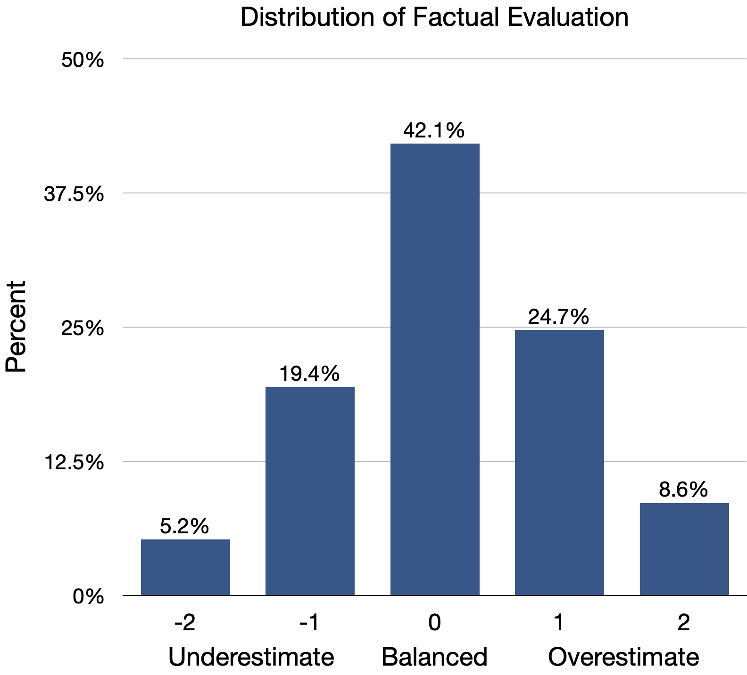

To see how Chinese respondents view inequality in greater detail, we can turn to a question about what social structure graph most closely reflects the makeup of Chinese society. From this, it seems that the majority of respondents are aware that China has an unequal social structure in absolute terms, one which mimics the shape of a pyramid seen in response B Figure 1. Chinese citizens’ views about inequality in the U.S. are more divided. While 28.7% believe the US has an equal social structure that resembles the olive shape, nearly a quarter (23.4%) perceive U.S. to have the most unequal structure illustrated in E, with a great mass of people at the bottom and a small elite at the top.

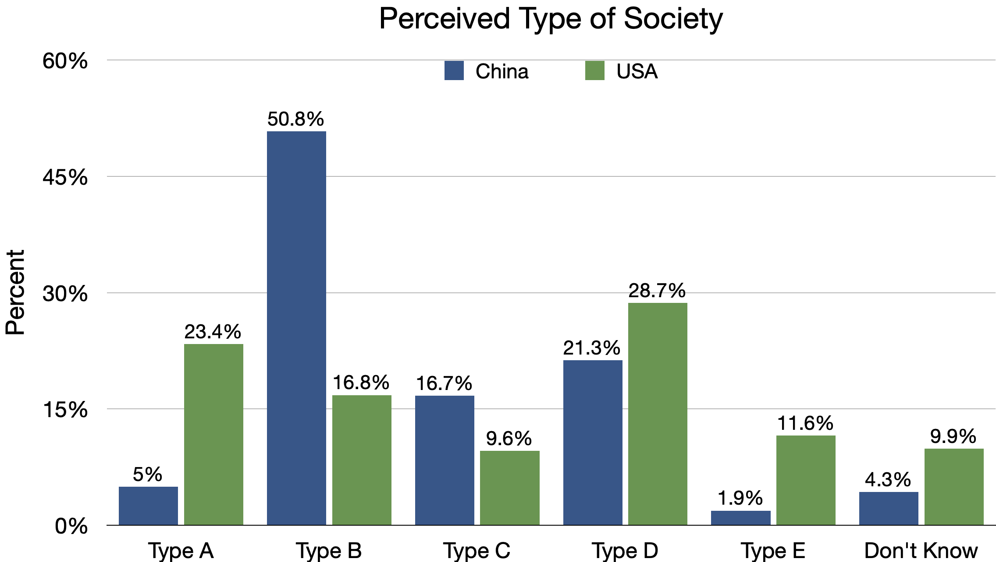

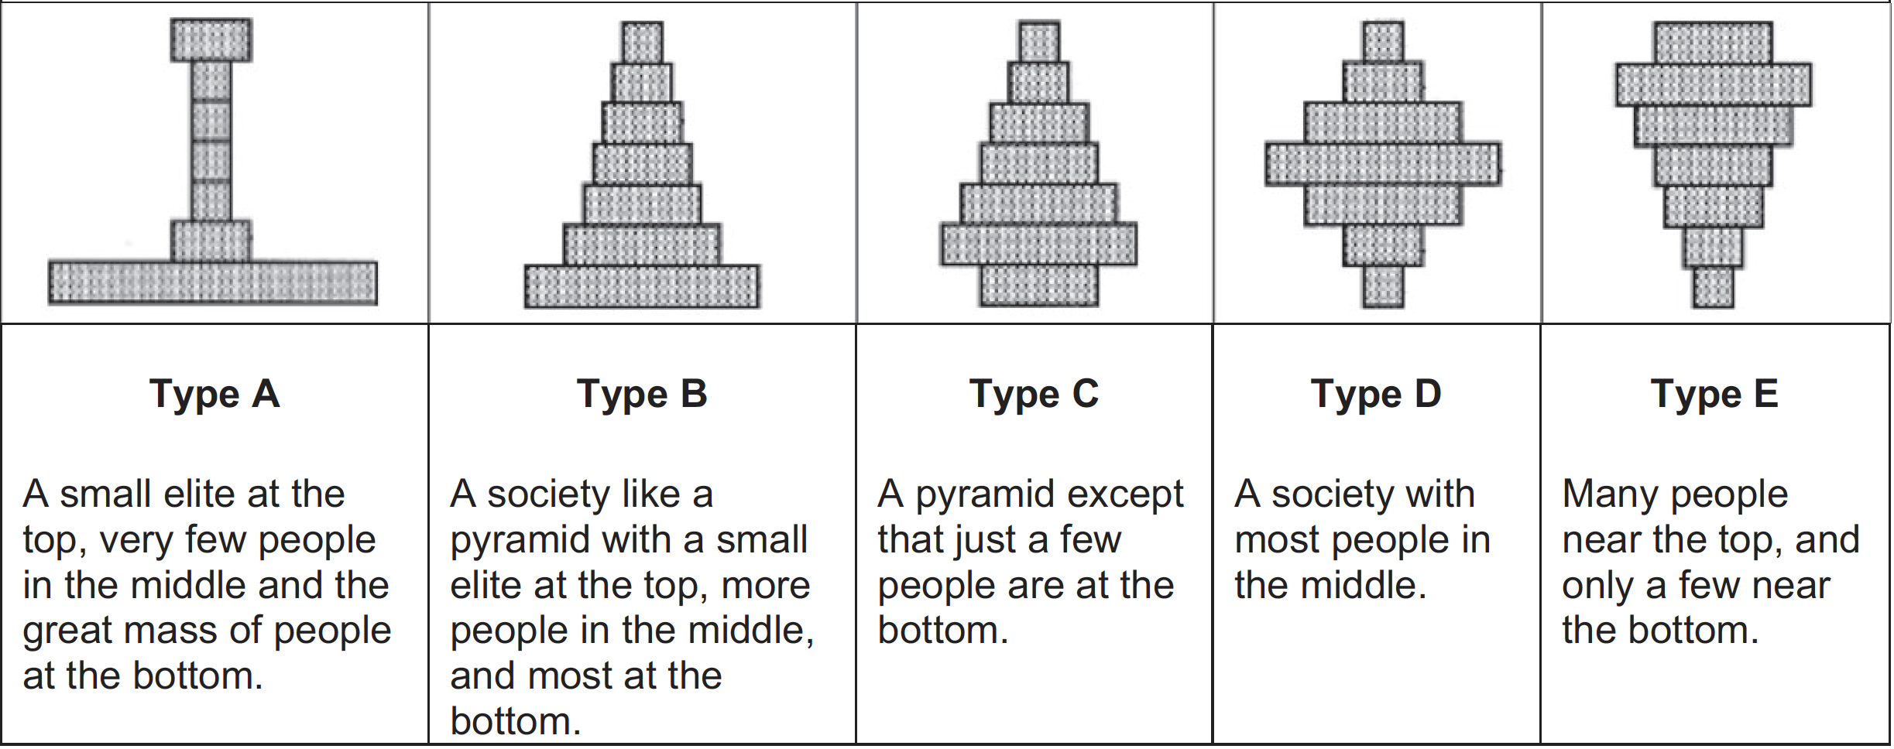

While the responses above indicate that Chinese respondents are clear that the social structure in China has issues with inequality, it appears they are more split as to its relative standing with the U.S., with potential implications for dissatisfaction with the regime.

If Chinese citizens perceive their problem to be severe relative to competitors, they may be more displeased with the actions of their regime than if they feel their problems to be tame by global standards.

In order to investigate the perceived severity of the problem of inequality, let’s go back to the source. We find that in other questions, Chinese people also tend to feel domestic inequality is more easily resolved and feel inequality in the U.S. is a more dire problem. In fact, about a third believe inequality is not a serious problem in China. Only 4.5% believe inequality is a very serious problem in China, whereas over 20% believe inequality is very serious in the U.S. This optimism may, in turn, help us understand high levels of satisfaction repeatedly found in surveys of Chinese citizens.

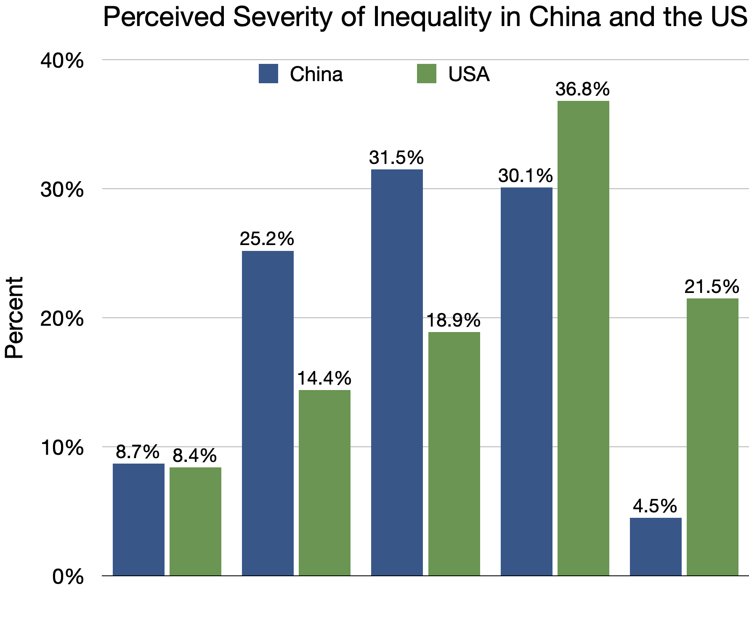

This is substantiated by respondents’ views towards the link between inequality and social instability. Only a few respondents (11%) worry that the gap between rich and poor in China becoming too large might cause social unrest. In contrast, they believe the rising income gap is a destabilizing factor for the U.S.

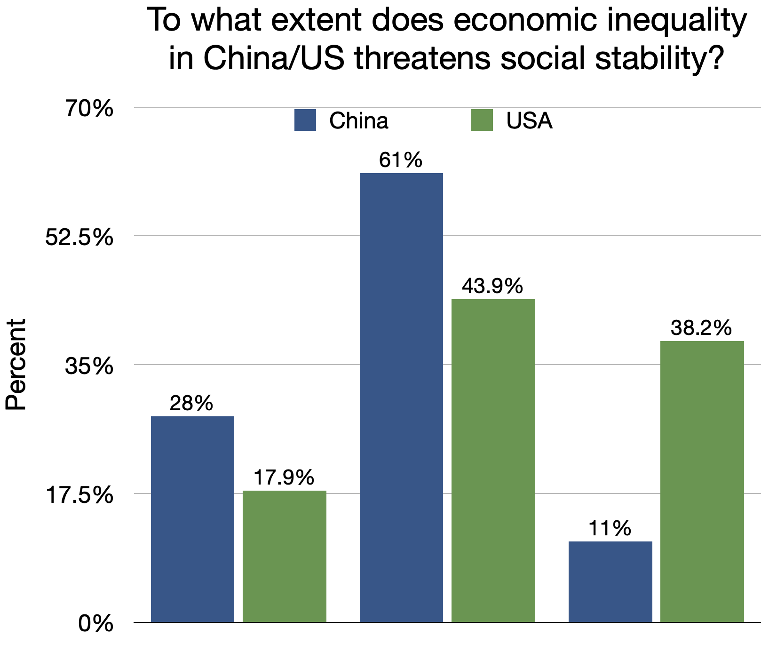

Chinese people’s views of domestic inequality are also reflected in their perceptions of inequality’s trajectory The majority of respondents believe income inequality in China has reduced or stayed the same in the past 5 years. They also believe the income gap will continue to decrease in the upcoming 5 years. In contrast, about half people think income inequality in the US has worsened and will continue to deteriorate. This optimism may be critical to understanding the broader picture of satisfaction with many aspects of the regime’s economic governance.

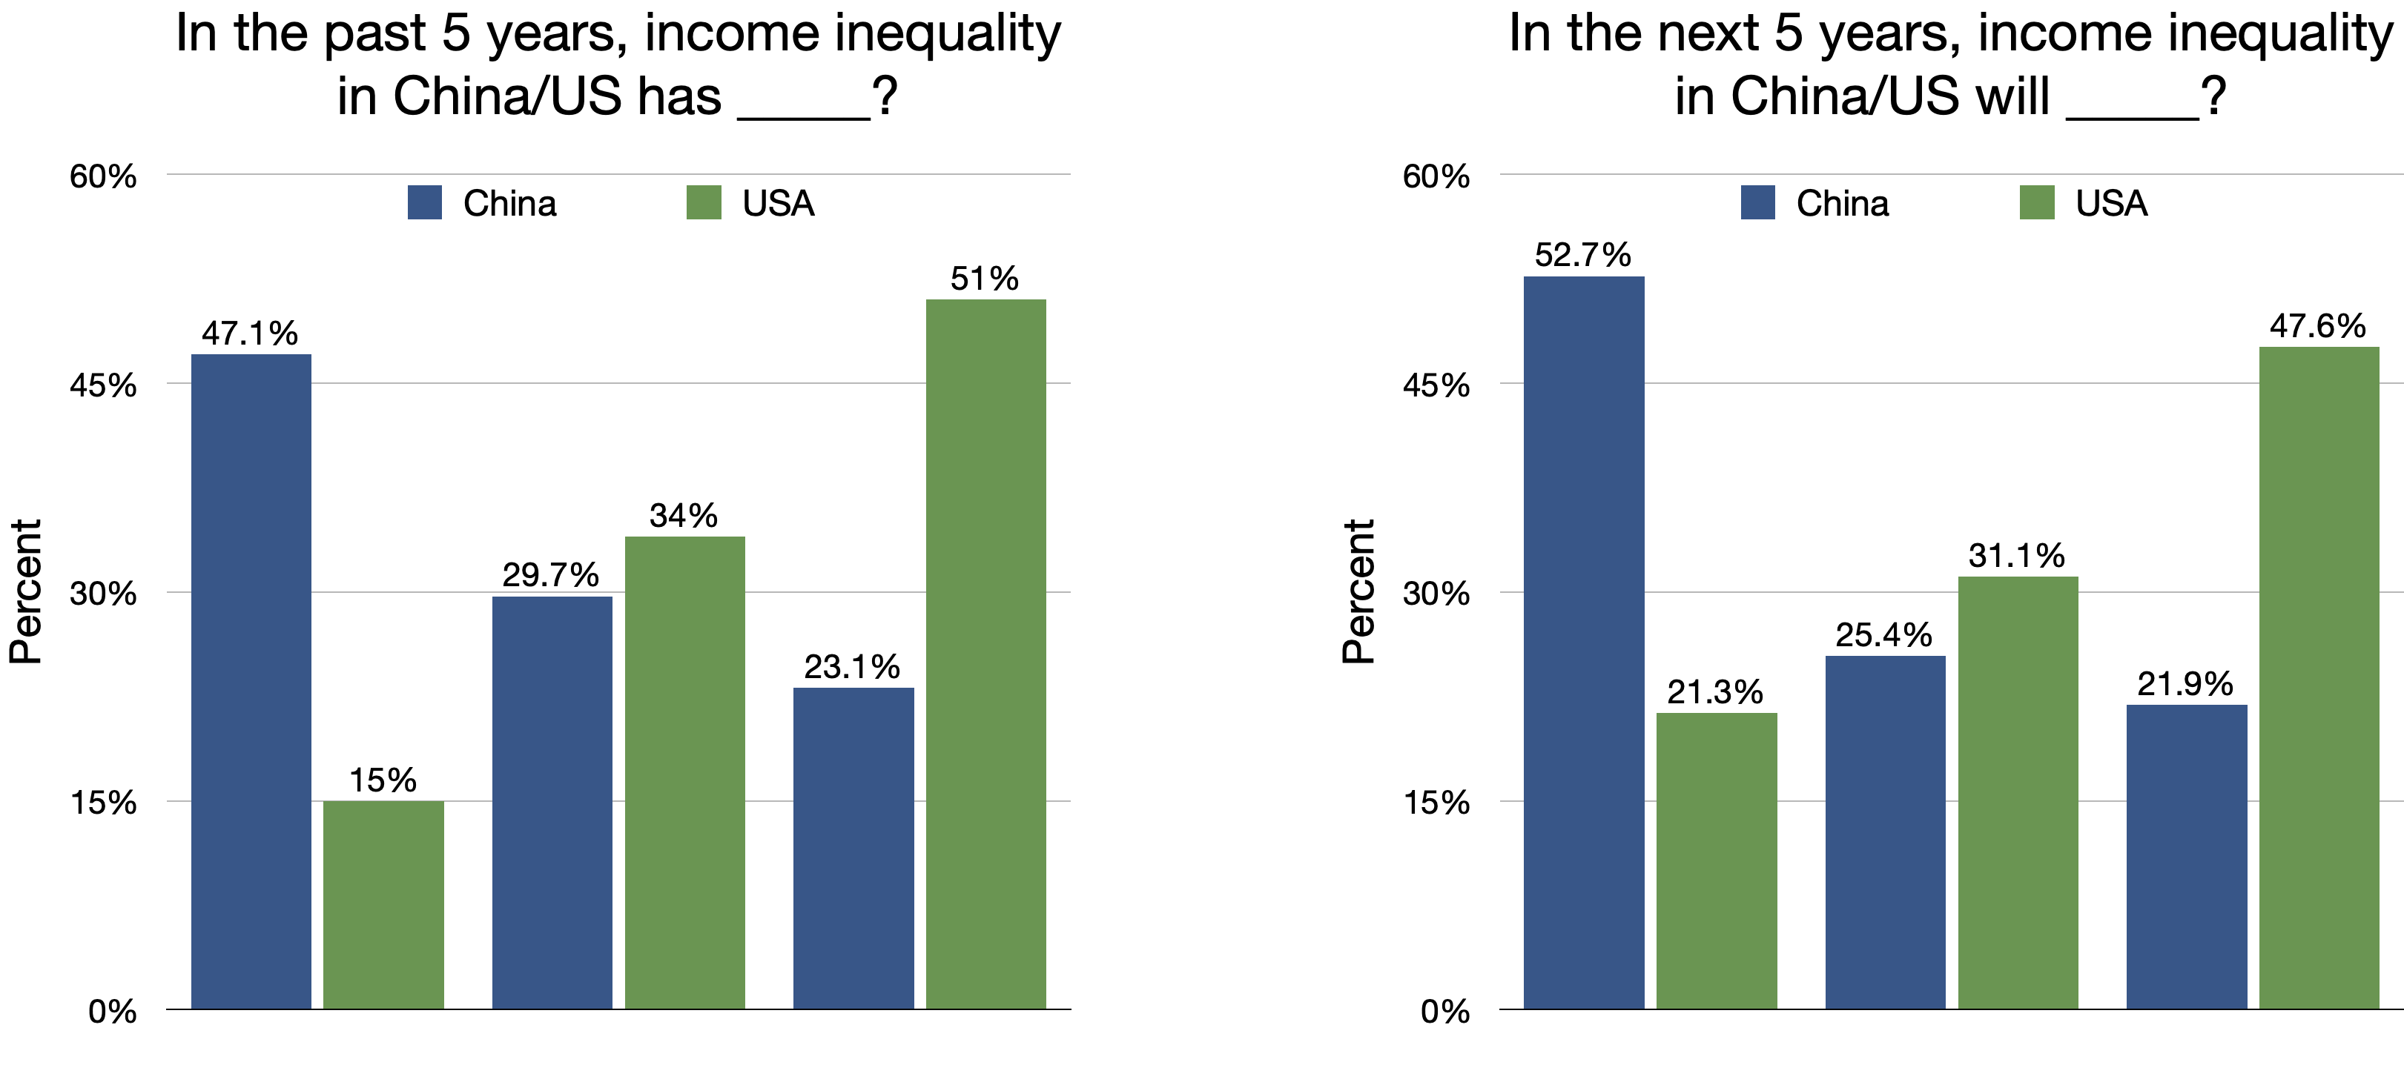

Interestingly, Chinese respondents appear to share perceptions common to Americans who discuss economic inequality as an issue of pulling oneself up by their bootstraps. When asked to list the primary reasons for inequality in China, the majority of people (53.4%) attribute to individual factors such as ability, effort, and education. When people blame external factors, they attribute the blame to the rich failing to help the poor, rather than blaming government policies. These perceptions of the root causes of inequality may further exculpate blame from the state, helping to further elucidate our understanding of regime satisfaction.

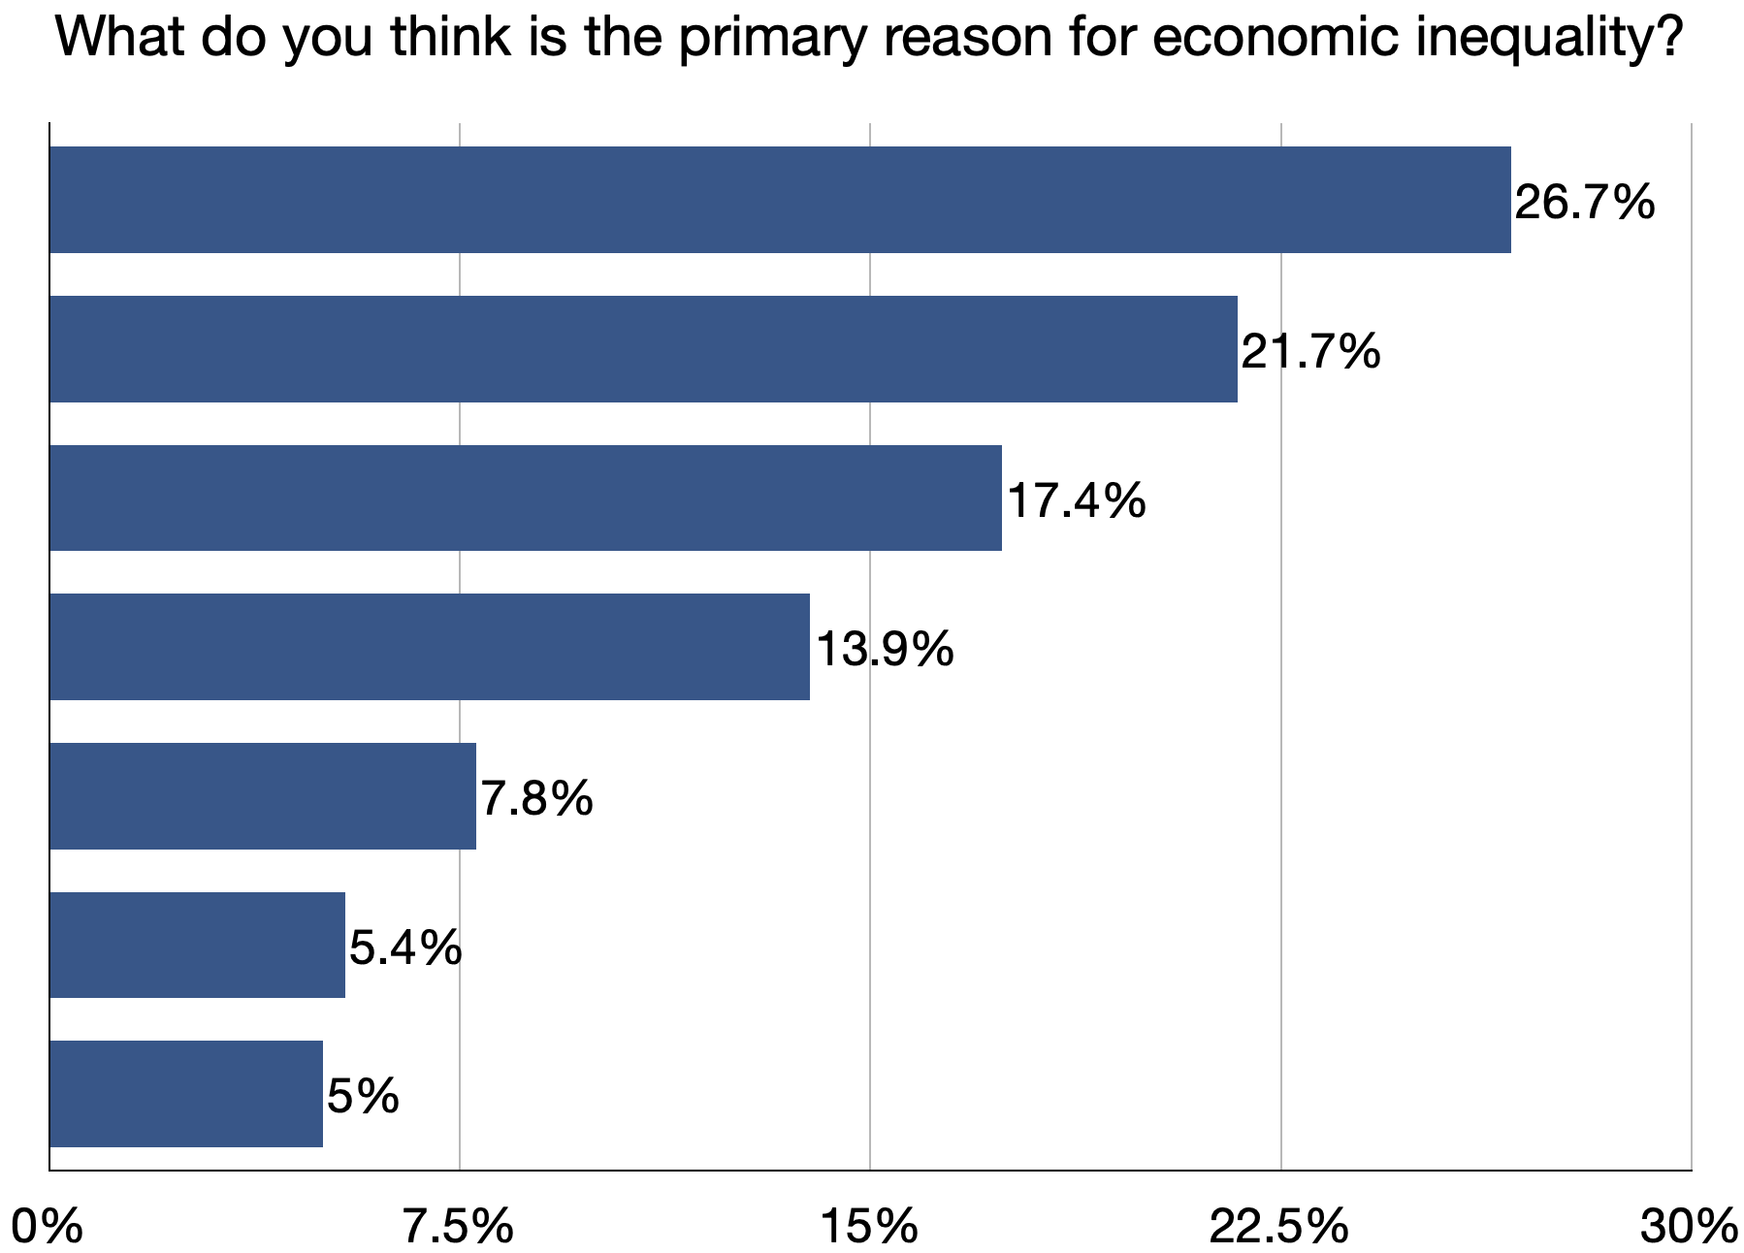

So what are the major takeaways from this study? We find Chinese citizens have relatively accurate factual beliefs about inequality in China. They are aware the Chinese society has an unequal economic structure where most people have a small fraction of national wealth. However, they do not think of this as a serious problem because they view the income gap as narrowing, believe the society as fair, and primarily blame individual factors such as ability for inequality. Finally, and critically, Chinese people think inequality is a bigger problem in the U.S., though many are aware the U.S. society has a more equal economic structure, perhaps due to nationalistic sentiment.

What, then, of Common Prosperity? From our survey analysis, it does appear that Chinese citizens are not yet entirely dissatisfied with the state of inequality in China, in part perhaps driven by perceptions of positive trends and a belief that individuals are responsible for their own poverty due to lack of effort or education. However, an ounce of prevention is worth a pound of the cure. While Chinese citizens may not believe inequality is a problem for unrest in their own country as of yet, their view of the U.S. indicates that they believe such inequality can indeed prove a massive stumbling block. Beijing’s efforts may be intended to stave off just that potential reality.

