Constructing Imagined Communities: How Does China Tailor Its Propaganda to Cater to Different Audiences?
– A Case Study of China’s Propaganda Campaign Against the 2019 Hong Kong Protests
Tong (Adam) Wu
University of California, San Diego

- Introduction
Empirical scholarship in the field of political science has extensively studied how modern authoritarian states use propaganda to advance their various political purposes over the past decades. Yet rarely do they discuss or provide any evidence on the variations in modern authoritarian states’ propaganda tailored to different target audience ceteris paribus. This paper intends to fill this vacuum by studying China’s internal and external propaganda campaign against the nine-month Hong Kong protest from March 31st 2019 to January 9th 2020. By analyzing China’s state media’s coverage of the protest on Weibo and Twitter, this paper finds that China’s internal and external propaganda significantly differ in their content when covering the same event for the different target audience. Internal propaganda is more likely to use symbolic language to emphasize nationalism than external propaganda targeting non-Chinese speaking audience. Such a difference in evoking nationalism becomes less salient when comparing internal propaganda with external propaganda targeting overseas Chinese-speaking audience.
- Theoretical Motivation:
Since the power of using mass media to demonize enemies and reap the masses’ support for wars was uncovered in 1915 (Miller 2004), governments around the world, both democratic and authoritarian alike, have been actively employing and exploiting this technique and its derivatives – later together called as “propaganda” – for their various political purposes. Compared to their democratic counterparts, authoritarian leaders across the political spectrum seem to be more inclined to boast their use of propaganda despite its pejorative connotation. Mao Zedong, the immortal helmsman of the Communist Party of China, explicitly refers to propaganda as the Red Army’s “first major work”(Mao 1929). In Nazi Germany, der Führer eulogizes propaganda as a form of art that, if applied correctly, could make “heaven palmed off on a people as hell and, the other way around, the most wretched life as Paradise”. (Hitler, 1941)
Entering the 21st century, the information explosion on the internet and the development of social media together makes authoritarian governments’ penchant for using propaganda to advance their political agenda grow stronger and more conspicuous, which, as a result, creates favorable conditions for studying these propaganda strategies. A burgeoning number of empirical studies have emerged over the past decade. Domestically, propaganda is found to be used by authoritarian states to change citizens’ impressions on their governing competency (Rozenas and Stukal 2018), signal states’ strength to maintain political and social control (Huang 2015), and deter citizens’ rebellion (Edmond 2013). Internationally, existing literature has documented authoritarian states’ external propaganda campaigns to either influence other countries’ democratic elections (Faris, et al., 2017) or attempt to reshape their own images on the global stage (Tsai 2016). Additionally, scholars have also looked at some of the mechanisms that need to be in place for propaganda to bring about the desirable effects, such as the conditions for propaganda to induce compliance of the citizenry (Little 2017) and the effect of the cost of propaganda on states’ choices of propaganda strategies (Carter & Carter 2020).
These empirical scholarly works have together delineated a relatively complete picture of modern authoritarian states’ propaganda universe. Nevertheless, the discussion about a crucial component of propaganda is still missing in these empirical studies, which is how authoritarian states tailor their propaganda to cater to different target audiences. This question is particularly important in that the variation in different target audience groups is an essential determinant of how authoritarian states propagandize their agenda. In theory, propaganda is never indiscriminately aimed at people regardless of their beliefs and ideologies but rather functions via an initial selection of a target within the population. Built upon Max Weber’s theory of social stratification and classification, for instance, Jason Stanley argues that propaganda is “the means by which the highly privileged group in society controls negatively privileged groups” (Stanley 2015). According to Weber’s theory, the people sitting at the top of the social pyramid – either by birth or by choice – often have an unceasing need to legitimize their privileged status within the human society (Weber 1954). After reconciling themselves to their social privileges and the inability to comprehend social injustice through a set of flawed ideological beliefs, the privileged groups will seek to rationalize such beliefs within the entire society to legitimize their privileged status. Propaganda, as Stanley believes, offers the conduits for the privileged groups to disseminate and, if used correctly, reinforce such beliefs among the negatively privileged groups, i.e., the masses. By targeting the linguistic and epistemic features of the masses through propaganda, the privileged groups could effectively force the masses to adopt the dominant narratives and consolidate their privileged status.
Jacques Ellul, the French philosopher and one of the most influential thinkers on propaganda in the 20th century, presents a more vivid illustration of the importance of target selection in propaganda. In Ellul’s framework, propagandists’ goal, in its simplest form, is to make their audience conform. Since the audience differ in almost every individual characteristics such as tendencies, desires, needs, psychic mechanisms, conditioning etc., propagandists need to aim at disarming the psychological defense of the small audience groups first. Only after successfully transforming the psychological state of the small targeted audience groups can propagandists take “total action” to appeal to a broader audience later. Ellul compares the process of propagandists targeting small audience groups to how medical technicians treat their patients.
“The propagandist thus becomes more and more the technician who treats his patients in various ways but keeps himself cold and aloof, selecting his words and actions for purely technical reasons. The patient is an object to be saved or sacrificed according to the necessities of the cause.” (Ellul 1965)
A perhaps even more concrete and up-to-date account of how modern propagandists, especially the ones adept at using modern technology to further their agenda, target specific audiences to increase the “potential effectiveness” of propaganda can be found in Garth Jowett and Victoria O’Donnell’s study of propaganda and persuasion. In their theoretical framework, the concept of “audience selection” no longer confines to either the “privileged vs. unprivileged” dyad or the abstract and somewhat figurative “small groups with various characteristics”. The masses’ prevalent and careless use of the Internet and social media has left a wealth of digital footprints, which propagandists could easily follow to trace and discern their target audience’s traits and further customize their propaganda strategies. Consequently, modern propagandists, equipped with all the digital monitoring tools and mechanisms, are now capable of further partitioning their target audience into more concretized segments, such as ethnic groups, interest groups based on industrial or sectoral interests, cultural and political elites, opinion leaders etc. and target them accordingly (Jowett & O’Donnell 2018).
The abovementioned development of propagandists being more adept at harnessing modern technology to prey on their target audience is particularly alarming in the context of authoritarian politics. With the absence of broad democratic support, authoritarian states have always been on guard against the masses’ revolt since revolts in authoritarian settings are more often driven by the masses’ desire to bring down the existing institutions of authoritarian government (Mesquita & Smith, 2011). Traditionally, authoritarian states like East Germany’s communist regime would resort to methods such as surveys to detect the masses’ true values, beliefs, and attitudes, hoping to gauge their true political preferences and deter any potential threats pre-emptively. Since the masses could falsify their personal preferences for fear of being punished for revealing their animosity towards the regime, authoritarian rulers more often found themselves kept in the dark since the traditional methods often failed to capture the masses’ true preferences (Kuran 1991).
Nevertheless, the development of modern technology has fundamentally changed that situation for two reasons. Firstly, instead of falsifying their political preferences in public, people today are more inclined to spontaneously divulge their true political preferences since the prevalent use of social media has lowered the barriers and created several incentives, such as all the social media indicators for virality, for personal expression online. Coupled with certain peculiar occasions including anniversaries or politically controversial events that tend to spur people to express their political opinions, the social media boom has substantially lowered the cost of and increased the probability of authoritarian states succeeding in detecting the masses’ true political preferences. In fact, some authoritarian states such as China have not only figured out people’s true political preferences and the pattern of their expression but also developed and adopted countermeasures to dissuade people from translating their political expression into collective actions, such as censoring social media posts that could potentially spur social mobilization (King, et al., 2013) and fabricating pro-government social media posts ahead of sensitive anniversaries to divert people’s attention (King, et al., 2017).
The availability of the new countermeasures exemplified above is the second reason worth noting. Historically, since the traditional methods such as surveys could hardly rule out the masses’ preference falsification, many of the authoritarian states could only choose between succumbing to the masses’ demands or putting down their revolts in a costly way by force (Acemoglu & Robinson, 2006). The emergence of modern technology, however, has diversified authoritarian states’ toolkits, allowing the states to use censorship and propaganda to not only suppress the masses’ demand with a soft and relatively less costly approach but also preemptively nip any threats from the masses in the bud (Treisman & Guriev, 2019). Apart from the examples in China, informational autocrats around the world, such as Vladimir Putin, have also been using propaganda to change Russian audience’s perception of the regime’s domestic performance and distract citizens from expressing their political grievances through collective actions (Lamberova & Treisman, 2020). As detecting the masses’ true political preferences becomes much easier and the cost of propagandizing their agendas much cheaper, it is predictable that authoritarian states will have more incentives to use and perfect various propaganda techniques in the digital age including target selection, which makes studying it more urgent than ever before.
- Empirical Motivation
Despite the urgency to study and understand the variations in modern authoritarian states’ propaganda that target different audiences, empirical studies of authoritarian propaganda have rarely paid any attention to this facet yet. In many of the empirical works on China and Russia’s propaganda strategies, for example, scholars often consider the audience as a monolithic group, such as the “citizens” or the “masses”. Without comparing propaganda that targets different audience ceteris paribus, these studies could risk losing the intricacy and nuances that could reveal the use of an vital propaganda technique in authoritarian states and the political thinking behind it.
To fill this vacuum, I argue that China’s state media’s coverage of the protests in Hong Kong from March 31st 2019 to January 9th 2020 against the city government’s proposition for passing the anti-extradition bill on Sina Weibo and Twitter presents a rare opportunity for studying the variations in authoritarian states propaganda targeting different target groups for three reasons.
Firstly, the Chinese authority’s ambition to perfect its propaganda techniques, including better harnessing both internal and external propaganda, justifies this paper’s approach to set them apart. Since ascending to power, China’s supreme leader Xi Jinping has repeatedly emphasized the importance of propaganda and the urgency to perfect and harness propaganda techniques to fulfill the regime’s various political purposes (Ni 2013; Zhang & Huang 2018). On several occasions, Xi has explicitly mentioned the importance of “orienting” both China’s domestic and international news coverage towards the correct direction and “adapting to the trend of customized and differentiated communication” (Xi 2016). In the fourth plenum of the 19th Party Congress, the plenary communique included “constructing a mainstream public opinion pattern with the coordination of internal and external propaganda” as an important aspect of “consolidating the ideological foundation” to deepen the modernization of China’s governing capacity (Xinhua 2019). It is hence beyond doubt that China’s top leadership has greenlighted and is attempting the differentiation of internal and external propaganda to more effectively control public opinion.
Besides, the current media landscape and political atmosphere in China guarantee state media’s faithful implementation of Xi Jinping’s propaganda strategy. Not long after Xi unpacked his blueprint for China’s propagandists, state media had begun to study the spirit of Xi’s remarks earnestly. People’s Daily, for example, parsed Xi’s vision for internal and external propaganda into the following key points in Table 1. (CPCNEWS 2015), clearly differing the goals of the two types of propaganda.
Table 1. People’s Daily’s Interpretation of the Goal of Internal vs. External Propaganda
Internal | External
- Carry out in-depth propaganda and education on socialism with Chinese characteristics and unite the people of all ethnic groups under the great banner of socialism with Chinese characteristics  - Strengthen the construction of the socialist core value system, actively cultivate and practice the socialist core values, comprehensively improve citizens’ morality, cultivate the sense of telling honor and disgrace apart, being righteous, making contributions and promoting harmony  - Always unite Party spirit with people’s characteristics  - Propagandize unity, stability, encouragement, and positivity  - Consolidate and strengthen mainstream thought and public opinion  - Improve the quality and standard; seize the right timing, degrees and effects to enhance attraction and inspiration; make the masses love to listen to, read and resonate with propaganda  - When it comes to major issues concerning political principles, we must take and strengthen the initiative, help cadres and the masses draw a clear line between right and wrong, and clarify vague understandings  - Innovate propaganda and ideological work; put the focus of innovation on the grassroots frontline | - Propagandize and explain the Chinese characteristics; elaborate that each country and nation has accumulated different historical and cultural traditions and domestic conditions. Countries’ development path hence inevitably has their own characteristics  - Make it clear that Chinese culture embodies the deepest spiritual pursuit of the Chinese nation and is a rich nourishment for the Chinese nation’s continuous growth and development  - Make it clear that the excellent Chinese traditional culture is the outstanding advantage of the Chinese nation and our deepest cultural soft power  - Make it clear that socialism with Chinese characteristics is rooted in the fertile soil of Chinese culture, reflects the wishes of the Chinese people, and meets the demand of China’s development

And after Xi declared that “state media must have the party as their surname” (CPCNEWS 2016), various state news agencies immediately pledged their allegiance to Xi, upholding whatever he had envisioned for conducting propaganda work (Zhuang 2016). Therefore, it is reasonable to believe that both the top-down instruction and the bottom-up compliance could ensure the state media’s faithful execution of Xi’s command to direct and customize internal and external propaganda.
The second reason that justifies China’s coverage of the protests in Hong Kong being a good option for studying the variations in propaganda targeting different audience groups is the technical feasibility of comparing propaganda on Weibo and Twitter. A decade of operation of the Great Firewall of China (GFW) has effectively dichotomized China’s cybersphere, which consequently renders separately observing China’s internal and external propaganda relatively easy and straightforward. The primary function of the GFW is essentially to create a de facto virtual enclave within the world’s cybersphere by blocking mainland citizens from accessing information that the Communist Party of China finds objectionable (Clayton, et al., 2006). Due to the high restriction of cross-GFW mobility, a fait accompli resulted from the operation of the GFW is that the traits and behaviors of users inside and outside the GFW are greatly different. Take Weibo and Twitter as an example. Research has found a significant difference between the user behaviors on the two most representative microblogging platforms inside and outside the GFW. Some findings include Weibo users being less likely to embed hashtags and URLs in their posts but have a stronger tendency to publish positive messages than Twitter users (Gao, et al., 2012). With these differences in mind, propagandists who straddle the GFW must tailor their content and services to the entirely different target audience groups inside and outside the GFW to maximize the efficiency and effectiveness of the communication. In the case of Weibo and Twitter, this feature hence allows me to directly interpret the content posted by China’s state media on the two platforms as propaganda that respectively targets the domestic and international audience.
Last but not least, the CCP’s perception of the nature of the Hong Kong protest should theoretically incentivize China’s propagandists to differentiate and customize their propaganda that targets different audiences both at home and abroad. As discussed earlier before, authoritarian rulers are often more wary of mass protests than their democratic counterparts since these protests in the authoritarian setting more often serve as an indication of the masses wanting regime change. For communist regimes, the concern about mass protests is particularly acute since the idea of western democracies maneuvering citizens in communist countries to overthrow the regimes has been haunting them for decades.
In China’s case, this concern derives from Mao Zedong’s obsession with the notion of “peaceful evolution” that was first coined by the former state secretary of the United States John Foster Dulles back in the 1950s. Built upon historian George F. Kennan’s observation on the status quo of “peaceful coexistence” between the capitalist and communist bloc after World War II, Dulles amended the phrase to “promoting peaceful evolution towards democracy” in speeches of 1957-58, which was later perceived by Mao as a “deceptive tactic” aiming at “corrupting” the communist bloc and China (Saussy 2001). The paranoia did not go away in China after Mao died. Contrarily, it aggravated and eventually culminated at the end of the 1980s when a couple of communist regimes in Eastern Europe collapsed and months of student protests in Tiananmen Square ended in bloodshed. To recap Deng Xiaoping’s reflection in the post-Tiananmen period, “peaceful evolution” during the 80s was the “World War III without gunsmoke” waged by the “western imperialists” to incite “generations of our people” to “take down the Party”, “overthrow the socialist system”, and “establish a bourgeois republic completely subservient to the West” (Deng 1989).
The focus on economic development and reintegration into the world gave China a precious respite in the 1990s. Entering the 21st century, however, the country was alerted again by what was considered as the apparition of “peaceful evolution”. After several civil resistance movements, later together dubbed as the “color revolution”, occurred in countries that were former Soviet states, Chinese leaders, beginning with Xi Jinping’s predecessor Hu Jintao, began to voice concerns about the reemergence of the western scheme to incite the masses to revolt against China’s communist regime (Chen 2010). Such a concern has persisted and, to some degree, also has been exacerbated in Xi Jinping’s administration. Both Xi himself and the Minister of Public Security Zhao Kezhi, for example, have extensively talked about how “the western countries plot ‘color revolution’ by …manufacturing and exaggerating public opinion…inciting the public to engage in street politics”(Xi 2015) and the urgency to “prevent and resist the ‘color revolution’ to ensure political security”(Li 2019). More importantly, Zhang Xiaoming, the then director of the Hong Kong and Macao Affairs Office of the State Council, said in August last year that the Hong Kong protest had begun to exhibit “characteristics of ‘color revolution’”(Chen, et al., 2019). This deep concern about western countries’ attempt to use the protests in Hong Kong to foment “color revolution” against the Party, along with the earlier discussion about Xi Jinping’s instruction on differentiating and customizing China’s internal and external propaganda, together suggests that China’s propagandists would likely to adopt different strategies when talking to the domestic and international audiences.
A perhaps even more important reason that justifies the use of China’s coverage of protests in Hong Kong for studying propagandists’ target selection is how China, under Xi Jinping’s command, has been stepping up its united front work on ethnic Chinese living outside the mainland. Historically, united front work was viewed by the CCP leaders as one of the “three treasures” that the Party relies on to broaden its support among the masses. Within the monolithic concept of the “masses”, Chinese living outside mainland China, including mainland Chinese nationals living overseas, ethnic Chinese living in Hong Kong, Macau and Taiwan, and foreign citizens of Chinese descents, are a subgroup that the CCP tends to pay special attention to when conducting united front work. Previously, the efforts to appeal to the overseas Chinese community was oriented towards encouraging them to make business investments on the Mainland and support China’s reunification with Hong Kong, Macau, and Taiwan. After entering the 21st century, however, the CCP began to recalibrate its relationship with the overseas Chinese community and change some of the goals of the united front work accordingly. When Hu Jintao was in office, for instance, he categorized the “relations with compatriots both at home and abroad” as one of the five major political and social relations that China needs to deal with and began to talk about instilling “the sense of identity and pride” in the overseas Chinese’s mind through Chinese-language education (Hu 2006).
Since Xi Jinping came to power, the CCP leadership has elevated the united front work on the overseas Chinese community to a whole new level. It is noteworthy that Xi previously worked at the various levels of governments in China’s Fujian province, the “hometown” of a large proportion of China’s diaspora for 17 years. Xi’s first-hand experience of dealing with the overseas Chinese affairs in Fujian prompted him to develop his own vision for interacting with ethnic Chinese living outside mainland China in the future. Contrary to the views of CCP elders, including his father Xi Zhongxun, Xi Jinping explicitly pointed out in an essay penned in 1995 that he would prefer a more pre-emptive rather than reactive approach to deal with the overseas Chinese community. Instead of respecting “national boundaries” to avoid “perplexing and discomposing the host countries of the ethnic Chinese people” as his father would suggest (Xi 1984), Xi Jinping believes that united front work targeting the overseas Chinese community should be more aggressive and focused on the younger generations. It should “break the territorial boundaries”, aim at “evoking the sense of identity with and nostalgia for the homeland”, and involve all levels of government and party apparatus rather than rely on overseas Chinese affairs office alone (Xi 1995). After ascending to power, Xi quickly translated his words into actions by issuing a series of regulations to overhaul the system that deals with the overseas Chinese affairs (Xinhua 2016), move it from the government to the CCP united front department, and use nationalist rhetoric to appeal to the overseas Chinese community (CCTV 2019). Since the protests in Hong Kong are of direct interest to many in the overseas Chinese community, it is hence reasonable to believe that Chinese propagandists will further fine tune their overseas propaganda to reach different parts of the foreign audience and customize their external propaganda accordingly.
- Description of Data
To study the variations in China’s internal and external propaganda, I use the platform where the propaganda content is disseminated and the language in which the propaganda is written as the criteria to discern the difference between internal and external propaganda. For the platform, prior research, as mentioned above, has detailed the difference between the user behaviors on Weibo and Twitter. As for language, disseminating propaganda in the “common tongue” used by the target audience is widely documented in the literature as a common practice to increase efficiency and effectiveness (Stanley 2015; Jowett & O’Donnell 2018). I hence constructed three datasets with Weibo posts and tweets in simplified Chinese, English, and traditional Chinese from Xinhua News Agency, People’s Daily, and China News Service (CNS). For the sake of brevity and clarity, this paper will hereafter address these three news agencies together as the “propaganda group”.
Due to the restriction of cross-GFW mobility mentioned above, the Weibo posts in simplified Chinese can be viewed as propaganda that targets users born and still live in Mainland China, i.e., internal propaganda. The English tweets on Twitter, on the other hand, targets\ the non-Chinese speaking foreign audience capable of reading English, i.e., external propaganda in English. The tweets in traditional Chinese target four types of ethnic Chinese audiences who can access information outside the GFW, i.e., external propaganda in traditional Chinese. The four subtypes of the audience in this group including
- Chinese citizens born in the Mainland but currently live outside the Mainland
- Chinese citizens born and still living in the Mainland who are capable of circumventing the GFW by using VPN and virtual proxies
- Ethnic Chinese born and still living in Hong Kong, Macau and Taiwan
- Foreign citizens of Chinese descent both born and living outside the mainland
All the social media content used in this paper are posted by the propaganda group (Xinhua News Agency, People’s Daily, and China News Service) between March 31,2019 when the first wave of protest against the extradition bill in Hong Kong occurred (Singh, et al., 2019) and January 9, 2020 when Luo Huining – Beijing’s newly appointed head of the Hong Kong Liaison Office – met with the city’s incumbent Chief Executive Carrie Lam (Cheung, et al., 2019). To capture as many social media posts that are related to the Hong Kong protest as possible, I used a series of keywords and their linguistic variations to filter out the three datasets. Table 2 displays the basic statistical summary for all the three datasets. When the content in the comparison groups is not written in the same language, I used Google Translate API to translate one side into the language used by the other so that every dataset can later be analyzed under the same topic model.

TABLE 2. Data Description
Datasets | Description | Number of observations in total | Language for Analysis
1 | Propaganda Group’s English Tweets vs. Neutral News Agencies’ English Tweets | 10,234 | English
2 | Propaganda Group’s Weibo Posts in Simplified Chinese vs. Propaganda Group’s Tweets in English | 4,873 | Simplified Chinese
3 | Propaganda Group’s Weibo Posts in Simplified Chinese vs. Propaganda Group’s Tweets in Traditional Chinese | 4,772 | Simplified Chinese

The first dataset is constructed for a baseline comparison between the propaganda group and the relatively more neutral news agencies to examine the biasness in China’s propaganda. After pooling the results of several studies of media bias, this paper decided on three international media outlets based in different countries as the neutral agency baseline, which are The Associated Press, Reuters, and Agence France-Presse. Ideally, it would be better if the paper could compare both the Weibo posts and tweets of the baseline group with the propaganda group’s. Yet due to China’s restriction of foreign media’s operation inside the GFW, the vast majority of the international news agencies, including the three selected as the baseline here, either are not allowed to have verified official account on Weibo or have their content on Weibo censored or self-censored. This paper will hence only compare two groups’ English tweets.
- Testable Hypotheses
To study China’s internal and external propaganda campaign in the context of the Hong Kong protest, I would like first to examine if China’s state media were indeed following Xi’s instruction to propagandize their agendas rather than objectively report on the protest. To achieve that goal, I will use the first dataset to compare the propaganda group with the baseline group to see if the pattern of reporting by the propaganda group demonstrates two classic features of propaganda that are well-documented in the existing literature.
The first testable feature is “false equivalence”, a logical fallacy that is frequently exploited by propagandists to further their cause. By definition, false equivalence refers to the comparison of two things that are seemingly equal or balanced yet different in essence. When propagandists intend to support or delegitimize argument A, they often like to build a narrative around a similar argument B and compare A to B. Since argument B according to the narrative is either right or wrong, argument A must be either right or wrong as well due to its similarity with B. If China’s state media’s coverage of the Hong Kong protest is indeed a practice of propaganda, the paper should expect to see the use of “false equivalence” to be more likely associated with the propaganda group than the baseline of foreign media.
The second feature is selective reporting. According to the study of press coverage of protests in the existing literature, large protests organized by established groups with their concerns presented in predictable ways at predictable places where reporters tend to congregate are more likely to be reported by the media (Oliver & Myers 1999). Yet the principle of selecting information to cater to the target audience dictates that propagandists would never indiscriminately cover all the protests even if all the protests that are available for reporting meet the criteria mentioned above (Jowett & O’Donnell 2018). It is reasonable to anticipate that the propaganda group is less likely than the baseline group to cover all forms of protests even though the former has the same access to these protests as the latter. Put everything above into consideration, this paper proposes the first hypothesis:

H1: The propaganda group’s coverage of the Hong Kong protest is less neutral than that of the baseline group
H1.A: The propaganda group is more likely to use “false equivalence” in its coverage of the protest than the baseline group
H1.B: The propaganda group is less likely to cover all forms of protests in Hong Kong than the baseline group

The second hypothesis considers the difference between the propaganda group’s internal and external propaganda through the analysis of the second dataset. Amid international crises or facing external pressure, authoritarian states, according to the existing literature, would sometime mobilize their citizens’ nationalist sentiment to either signal their strength to the foreign forces or increase their bargaining chips in negotiations with foreign countries (Weiss 2013). Mass media, as also shown in the literature, often provides the technical means for the construction of nation in a conceptual sense – the imagined community from which the nationalist sentiment is derived (Anderson 1983). In China’s case, the CCP has been known for its attempt since the Tiananmen turmoil in 1989 to consolidate its rule by evoking Chinese people’s nationalist sentiment to construct a nation-state (Zhao 2004). To construct such a nation-state in the digital era, the country’s incumbent leader Xi Jinping has repeatedly emphasized the importance of using media to “unite the people in ideals, beliefs, values and moral concepts” (Xinhua 2019) and transforming the Internet to “the largest incremental force in building a common spiritual home for all ethnic groups and forging the community consciousness of the Chinese nation” (Yang & Wang 2019). Since Chinese leaders, as discussed in the sections earlier, perceive the protests in Hong Kong as part of the “color revolution” that is fomented by the west to topple the communist regime in China, it is reasonable to anticipate that propagandists in authoritarian states would attempt to rally the domestic audience under the banner of nationalism to resist foreign intervention.
When attempting to arouse nationalism with propaganda, propagandists often use symbolic language to rally the target audience under the same banner against a common enemy. According to the existing literature, symbolization can affect receivers’ perception of information through the associations they make with the symbols (Jowett & O’Donnell 2018). If applied correctly, the propaganda that manipulate sacred and authoritative symbols such as villains and heroes without being detected can, therefore, allude to receivers’ patriotic feelings and subsequently spark nationalist sentiments. Since nationalism often comprises and is associated with two essential components, i.e. territory and ethnicity (Barrington 1997; Anderson 1983), the propaganda group in this study could be expected to use symbolic language associated with these two concepts in its internal propaganda. The paper hence proposes the second hypothesis:

H2: The propaganda group is more likely to appeal to nationalism in its internal propaganda than external propaganda targeting the overseas non-Chinese-speaking audience
H2.A: Symbolic language associated with territorial integrity and national pride is more likely to be used in internal propaganda than external propaganda targeting the overseas non-Chinese-speaking audience
H2.B: Symbolic language implying foreign intervention is more likely to be used in internal propaganda than external propaganda targeting the overseas non-Chinese-speaking audience

The third hypothesis concerns the external propaganda targeting ethnic Chinese living overseas. As discussed in the earlier sections, China’s current supreme leader Xi Jinping has been pushing for a preemptive approach to evoke nationalism when conducting united front work targeting ethnic Chinese living overseas, suggesting that China’s propagandists would perhaps treat the overseas Chinese audience more like the domestic audience than the foreign non-Chinese speaking audience. Such a suggestion leads me to make the last hypothesis:

H3: The difference between the use of symbolic language for nationalist sentiment between domestic and international audiences, while it still exists, will be less obvious between internal propaganda and external propaganda targeting ethnic Chinese living overseas
To quickly motivate the examination of the three hypotheses, Appendix 3 shows the word cloud comparison of the three datasets that will later be analyzed for the three hypotheses. The next section will focus on introducing the statistical method and the findings.
- Quantitative Analysis with Structural Topic Model (STM)
To test the three hypotheses above, I will first use the STM model to further look into the three datasets listed above. The STM model, like other topic models, is a generative model of word counts but with the advantage of associating document metadata with the model’s topical prevalence and topical content (Roberts, et al., 2019). For the sake of consistency, I set the number of topics generated by the model to 10 for all datasets. To define the nature of each topic, I will consider all four of STM’s measurements of topic content – “Highest Prob”, “FREX”, “Lift”, “Score” – and the ten most representative words for each measurement within each topic. How Topic 10 in Dataset 2 is defined is shown here as an example to illustrate such processes.
Table 3: Top Words for Topic 10 in Dataset 2 (Internal vs. External Propaganda in English)
Highest Prob: | 港 | 暴力 | 乱 | 势力 | 分子 | 中 | 暴徒 | 人民 | 乱港 | 政治
FREX： | 锐评 | 例 | 乱港 | 乱 | 风波 | 安生 | 革命 | 黎智英 | 颜色 | 乱局
Lift： | 私利 | 黎 | 人心所向 | 信 | 充当 | 关乎 | 可谓 | 安生 | 无耻 | 柱
Score: | 信 | 势力 | 锐评 | 乱 | 乱港 | 黎智英 | 李柱铭 | 安生 | 正义 | 例

As shown in Table 3 above, the most representative words that characterize topic 10 in the second dataset conveys the following messages:
- Words including “chaos” (乱/乱局), “violence” (暴力), “violent mobs” (暴徒), “wreak havoc in Hong Kong” (乱港) together imply that violent protests are disrupting the stability in Hong Kong by creating chaos.
- Words including “color revolution” (颜色 + 革命), “turmoil” (风波) and “force” (势力) imply that the Hong Kong protest is part of a plot against China maneuvered by hostile western forces.
- Words including “Jimmy Lai” (黎智英), “Anson Chan” (安生), “Martin Lee” (李柱铭), “serve as” (充当), “private interests” (私利), and “shameless” (无耻) together suggest that some of the Hong Kong elites are selling their dignity to the hostile forces in exchange for private interests, which echoes China’s accusation of the three plus Albert HO being the “gang of four” who wreaked havoc in Hong Kong (Xinhua 2019).
Considering all the three aforementioned implications, I find that the propaganda content in this topic generated by STM can be best summarized as an attack on some of the Hong Kong elites being the western stooges and fomenting unrest in the city. I, therefore, categorize this topic as “Imperialists’ Running Dogs”. The list of all the 10 most representative words for all four measurements of every topic of interest can be found in Appendix 4.
  - Baseline vs. External Propaganda (English)
The first statistical analysis of the paper compares the baseline group with the propaganda group’s external propaganda. After the model generates ten topics and determines each topic’s prevalence and content, I constructed a binary variable called “propaganda” with the value of 0 indicating the baseline group and the value of 1 indicating the propaganda group. Figure 1 shows the result of interacting the topics generated from the first dataset under STM with the binary variable through the following function:
$$Topic=β_{0}+β_{1}*Propaganda+ϵ$$
Figure 1. Topical Difference Between Baseline & Propaganda Group
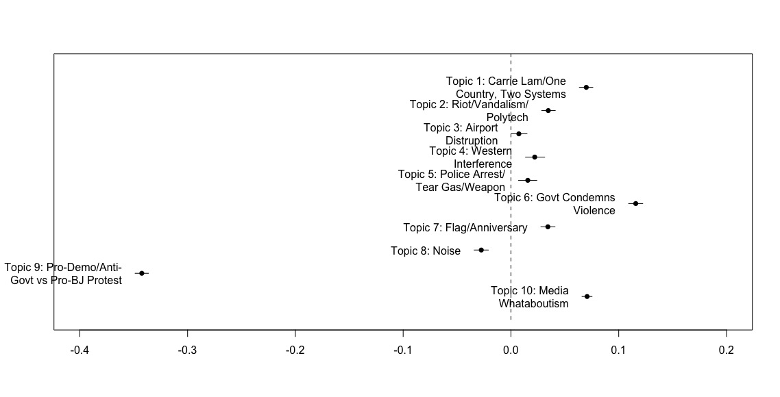
The topics of interest in Figure 1 are Topic 9 and Topic 10. Topic 10 that is defined based on its exclusive mention of the protests in Catalonia in October last year and the implicit comparison between the Hong Kong protest and the Catalonia protest corresponds to H1.A. Topic 9 that includes coverage of both the pro-democracy and pro-Beijing protests corresponds to H1.B. As shown in the figure, Topic 9 is more likely to be associated with the baseline group while Topic 10 with the propaganda group – a finding that appears to be consistent with the first hypothesis that China’s state media indeed carried out a propaganda campaign against the HK protest rather than reported on the protests objectively.
  - Internal Propaganda vs. External Propaganda (English)
To test the second hypothesis regarding the difference between China’s internal and external propaganda, I constructed a binary variable called “internal” with the value of 0 indicating external propaganda in English and the value of 1 indicating internal propaganda. Figure 2 shows the result of interacting the topics generated from the second dataset under STM with the binary variable through the following function:
$$Topic=β_{0}+β_{1}*internal+ϵ$$
Figure 2. Topical Difference Between Internal Propaganda & External Propaganda in English
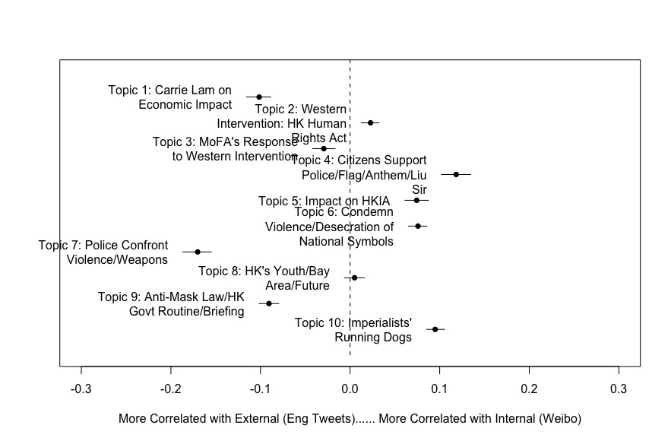

The topics of interest, in this case, are Topic 2, 4, 6, and 10. For Topic 4 and 6, the mention of national symbols such as national flags, the desecration of these symbols, and HK police officers who were lionized as national heroes make these two topics correspond to H2.A. For Topic 2 and 10, the emphasis on western countries’ intervention and the repeated attack on HK elites and student leaders who opposed police brutality make these two topics correspond to H2.B. As shown in Figure 2, all four topics are positively correlated with internal propaganda, suggesting that internal propaganda more likely appeals to nationalism than external propaganda when covering the Hong Kong protest.
To further examine the four topics that correspond to the second hypothesis, I also constructed a variable called “day” that is an integer measure of days from March 31st 2019 to January 9 this year and linearly interacted it with the “internal” dummy variable through the following function for each of the four topics:
$$Topic Prevalance=β_{0}+β_{1}*internal*day+ϵ$$
Figure 3. Change of Expected Topical Proportion (H2)
Topic 2: Western Intervention/HK Human Rights Act | Topic 4: Citizens Support/Police/Flag/Anthem/Liu Sir
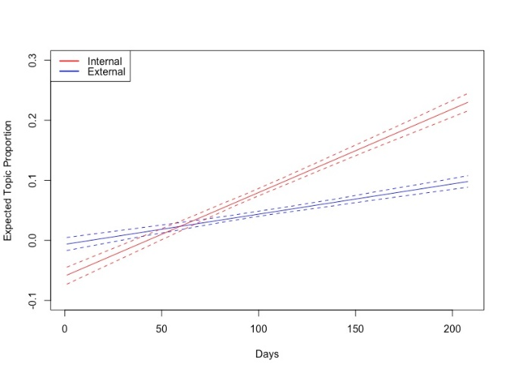 | 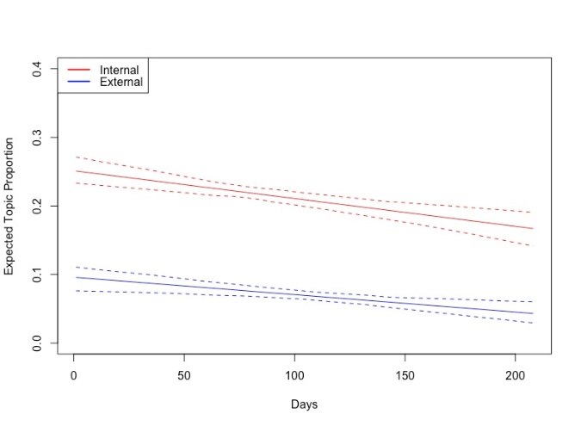
Topic 6: Condemn Violence/Desecration of National Symbols | Topic 10: Imperialists’ Running Dogs
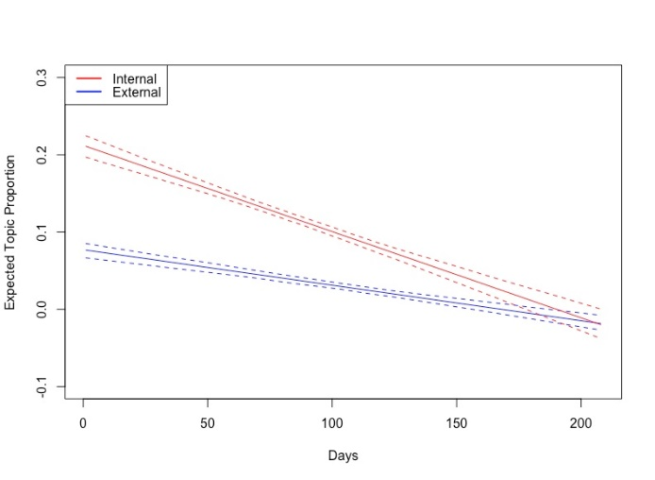 | 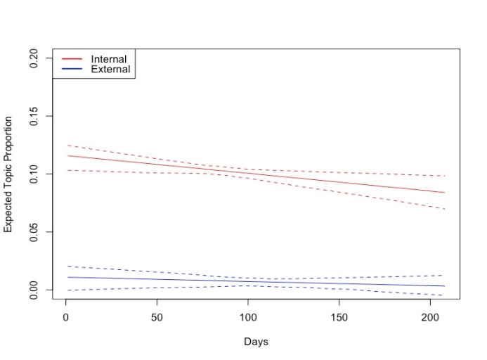

The changes in the expected topic proportion for Topic 2, 4, and 10 shown in Figure 3 are particularly interesting. For Topic 2, while the expected proportions of the topic for both internal and external propaganda increase throughout time, the proportion of content categorized as Topic 2 for internal propaganda increases significantly faster than that of external propaganda. Additionally, the expected proportion of Topic 2 in internal propaganda is over 10% higher than that in external propaganda in the most recent days. For Topic 4 and 10, although the expected proportion of both topics in both internal and external propaganda steadily decreases as time goes by, the proportion of both topics in internal propaganda consistently remains at about 10% to 15% higher than that in external propaganda, suggesting a persistent effort to propagate content related to these topics more aggressively in internal than external propaganda. The topical correlation between Topic 4, 6, 10, as demonstrated in Appendix 5.1, also suggests a coordinated effort to use nationalism in the propaganda campaign in general.
6.3 Internal Propaganda vs. External Propaganda (Traditional Chinese)
The last hypothesis to examine in the paper is regarding the difference between internal propaganda and external propaganda in traditional Chinese. Again, I created a binary variable called “mainland” with the value of 0 indicating external propaganda in traditional Chinese and the value of 1 indicating internal propaganda. Figure 4 shows the result of interacting the binary variable with the topics generated by STM for the third dataset through the following function:
$$Topic=β_{0}+β_{1}*mainland+ϵ$$
Figure 4. Topical Difference Between Internal Propaganda & External Propaganda in Traditional Chinese
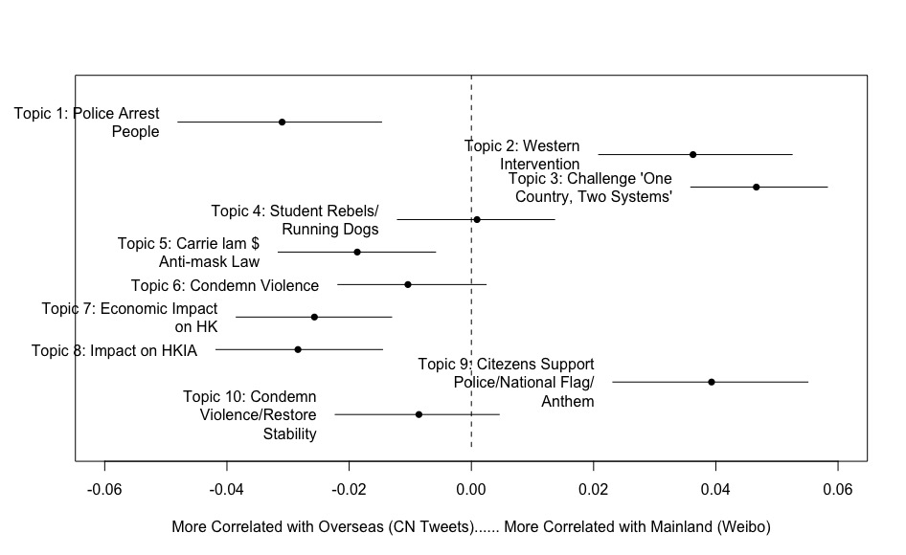
The topics of interest, in this case, are Topic 2, 3, 4, and 9. The content of all four topics is highly similar to that of the topics in section 6.2 above. Although Topic 2, 3, and 9 are still more positively correlated to internal propaganda than the external propaganda in traditional Chinese, the magnitude shown in the x-axis and that of each of the three topics are significantly smaller than the magnitude of difference demonstrated in section 6.2 for the second hypothesis. More importantly, the contents about propagandists’ attack on HK elites and student leaders are still distinctive enough in the third dataset that the STM model categorizes them into the same topic that is Topic 4. Yet unlike the finding for the second hypothesis, the correlation between the binary variable indicating internal and external propaganda in traditional Chinese and Topic 4 in Figure 4 is statistically insignificant, suggesting that the propagandists – as hypothesized in H3 – perhaps considered the mainland and diaspora audience the same when targeting them with contents attacking HK elites and student leaders. The coordinated effort to propagate such content is again found in topical correlations in Appendix 5.2.
Like section 6.2, here I constructed a variable called “day” that is an integer measure of days from March 31 2019 to January 9 this year and linearly interacted it with the “mainland” dummy variable through the following function for each of the four topics:
$$Topic Prevalance=β_{0}+β_{1}*mainland*day+ϵ$$
Figure 5. Change of Expected Topical Proportion (H3)
Topic 2: Western Intervention | Topic 3: Challenge ‘One Country, Two Systems’
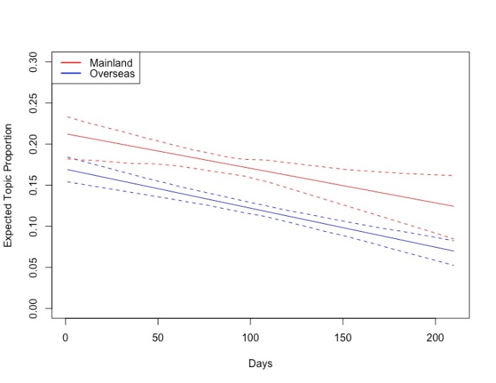 | 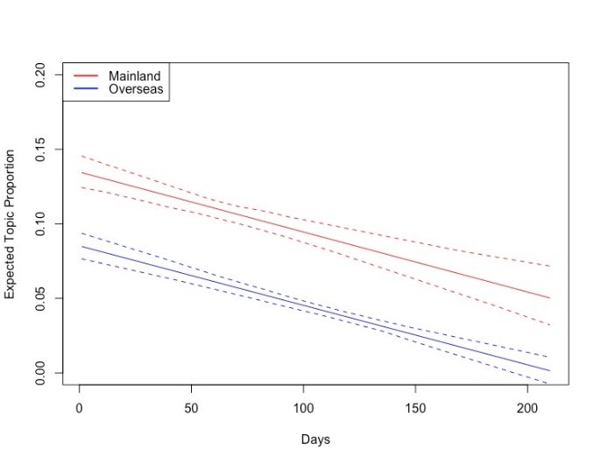
Topic 4: Student Rebels/Running Dogs | Topic 9: Citizens’ Support Police/National Flag/Anthem
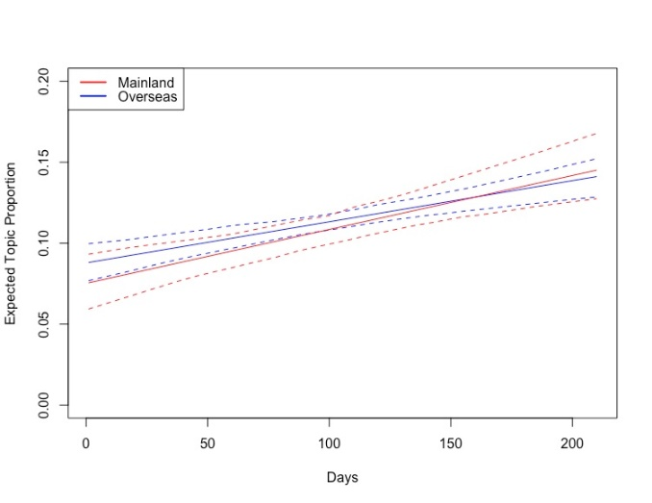 | 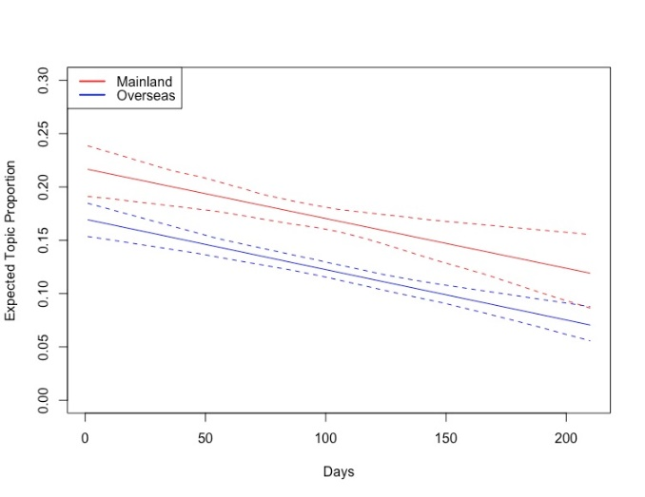
Figure 5 above demonstrates the findings of the interaction. For Topic 2,3 and 9, the expected topic proportion of all three topics steadily declined throughout the six month period while the proportions in internal propaganda remain larger than those in external propaganda targeting the Chinese diaspora. Interestingly, the persistent gaps of the expected proportion of all three topics between internal and external propaganda targeting Chinese diaspora are only about 5%, which is smaller than the gaps for Topic 4 and 10 in Figure 3. Moreover, the almost overlapping and identical trend of increase in the expected proportion of Topic 4 in Figure 5 further suggests that the propagandists see less of a difference between the mainland and diaspora Chinese audience.
- Qualitative testing: propaganda against Jimmy Lai
To further illustrate some of the propaganda techniques found in the quantitative analysis, this paper will examine a few posts by the propaganda group about Jimmy Lai from the datasets more closely through a series of qualitative analysis. As hypothesized in the earlier sections, propagandists would use symbolic and oversimplified language to evoke the audience’s nationalist sentiment either in support of a common hero or against a common villain. In the case of China’s propaganda campaign against the Hong Kong protest, few could be more fitting than Jimmy Lai – the HK media tycoon famous for his bold expression of pro-democracy views and efforts to draw attention from the international community to the HK protest – to be portrayed by China’s propagandists as the villain against whom all Chinese nationals must unite.
Lai’s concerns about the political future of Hong Kong and his rebellious spirit against Beijing are best encapsulated in an interview he gave to CNN on August 27th last year. In the interview, Lai expressed his hope for continuous spiritual support from the United States to the Hong Kong protesters and the willingness to exchange the city’s temporary economic suffering due to the halt of business caused by the protest for long-term political freedom (Marsh 2019). Both China’s internal and external propaganda campaigns quickly picked up Lai’s interview and responded with their takes. The following Table 4 and 5 show how People’s Daily and China News Service (CNS) covered Lai’s interview, respectively on Weibo and Twitter on August 29.
Table 4: People’s Daily’s Coverage of Lai’s Interview on Weibo
Original Weibo Post: | 【人民锐评：香港是时候为民除害了！】叛国乱港分子黎智英近日接受CNN采访，毫无廉耻地说要“谋求与美国共同的价值对抗中国”，公开宣称就是要“借港反中”，只要“国际压力加上经济放缓、就业职位流失，中国可能就会改变”，但同时还大言不惭：不担心自己，只担心香港，“已准备好战死”。如果不担心自己，就不会全家7本护照，随时准备跑路；如果不担心自己，就不会此时放出点声音，企图得到西方反华势力继续加持。他最近还宣称, 为了所谓“自由”可以让香港经济变差。这哪里是爱港，这就是赤裸裸的叛国卖港！帮他冲锋陷阵的“炮灰”们，该醒醒了：黎智英们随时会跑路，你们随时会沦为“弃子”。
Translation | [People's Sharp Comments: It's Time for Hong Kong to Eliminate Harm for the People! In a recent interview with CNN, Jimmy Lai, a traitor and Hong Kong rebel, said shamelessly that he would "seek common values with the United States against China". He openly declared that he wanted to "use Hong Kong to oppose China". As long as there are "international pressure plus economic slowdown and job losses, China may change". Meanwhile, he also brazenly boasted that he was not worried about himself but only about Hong Kong and was "ready to die". If you didn’t worry about yourself, you wouldn’t have 7 passports and always be ready to bounce. If you didn’t worry about yourself, you wouldn’t make any noise at this time in an attempt to get continued blessing from western anti-China forces. He also claimed recently that Hong Kong's economy could deteriorate for the sake of so-called "freedom". How is this loving Hong Kong? This is blatant treason and selloff of Hong Kong! The "cannon fodder" who charged headlong for him should wake up: Jimmy Lai will run away at any time and you will become "abandoned pawns" at any time.

Table 5: CNS’s Coverage of Lai’s Interview on Twitter in Chinese
Original Tweet in Chinese: | “乱港四人帮”头目黎智英日前接受CNN专访，乞求特朗普进一步介入香港，狂言即使经济变差也要继续动乱，更直认是要企图“借港反中”，称“国际压力加上经济放缓、就业职位流失，中国可能就会改变”
Translation | Jimmy Lai, the leader of the “Gang of Four who wrecked havoc in Hong Kong”, recently accepted an interview with CNN, begging Trump to further intervene in Hong Kong. He vowed to continue the turmoil even if the economy deteriorated. He even admitted directly that he was trying to "use Hong Kong to oppose China" and said that "international pressure coupled with economic slowdown and job losses may change China."

The propaganda techniques demonstrated in these two posts are revealing. Firstly, although it is true that Lai indeed said in the interview that he perceived the Hong Kong protest as a manifestation of the clash of values between democracy and authoritarianism and was fighting for the former, he never said anything in the interview close to the idea of “use Hong Kong to oppose China”. The clear-cut and defining quote was rather stuffed in Lai’s mouth by the propagandists. While it is also true that Lai said in the interview that international pressure coupled with an economic slowdown and job losses could change China, both of the propaganda posts truncated the other half of the quote in which he explained the change that he envisioned, i.e. Xi Jinping’s stepdown and the establishment of a more liberal government (Marsh 2019). In other words, what Lai has been fighting against, according to his own words, is the illiberal and authoritarian value represented by Xi Jinping’s administration rather than China as a nation. By fabricating quotes with clear-cut language and truncating Lai’s words, the propagandists constructed the image of Lai fighting against China as a nation, which creates the conceptual foundation for evoking nationalism from a broader target audience among Chinese nationals.
After substituting China as a nation for the illiberal value represented by Xi, the propagandists turned to Lai’s status within the “anti-China” rhetoric for further exploitation. For internal propaganda, propagandists gave Lai the title “a traitor and Hong Kong rebel” whose actions were tantamount to “treason and selloff of Hong Kong”, putting Lai on the opposite side of China’s national interests. It then went a step further to attack Lai’s personal integrity by suggesting Lai being a “political flip-flop”. The alleged “evidence” flaunted by the propagandists is that Lai, along with his family members, together have seven passports, meaning that he was involved in the protest all for his selfish gains and was ready to flee from HK and betray the movement anytime when his personal safety was in danger – a classic example of “false equivalence” between owning passports and ready to flee and betray the movement. For external propaganda targeting the Chinese diaspora, the title of “head of the Gang of Four who wreaked havoc in Hong Kong” directly tapped into Chinese nationals’ collective memory of Mao Zedong’s cultural revolution and the resentment at the role of the “Gang of Four”. In short, all the techniques listed above together transform Lai from a media tycoon advocating liberal democratic values against the illiberal and authoritarian repression into a cowardly race traitor masterminding the plot against the interests of the spiritual home shared by ethnic Chinese around the world that is called “China”.
A perhaps even more striking finding that is of the direct interest of this paper is how China’s external propaganda targeting the non-Chinese speaking audience reported on Jimmy Lai’s remarks and involvement in the Hong Kong protest in English. While the analysis above has demonstrated significant similarities between China’s state media’s coverage of the CNN interview for both the country’s mainland and diaspora audience, the external propaganda targeting the non-Chinese speaking audience did not even pick up Lai’s interview, suggesting a shift of focus when targeting different audience groups. To further examine such a difference, this paper looked back to a series of coverage of the “gang of four in Hong Kong” on both internal and external propaganda on August 19th and 20th. The following three examples demonstrate how China’s propaganda campaign covered the four elites for the three different groups of the target audience.
Table 6: CNS’s English Coverage of “Gang of Four” on Twitter, August 19
Original Tweet: | Hong Kong street Aug.3rd 2019, a fine restaurant in Hong Kong central Who are they? What are they doing? Celebrating? Plotting? Jimmy Lai, Martin Lee, Anson Chan, and Albert Ho--Gang of 4！
Translation | 2019年8月3日的香港街头，于一家位于香港中环的高级餐厅内。他们是谁？他们在做什么？庆祝？密谋？黎智英，李柱铭，陈方安生，何俊杰 – 四人帮！
Table 7: CNS’s Chinese Coverage of “Gang of Four” on Twitter, August 19
Original Tweet: | 8日，香港民阵“流水式集会”，“祸港四人帮”中的黎智英、李柱铭、何俊仁都到场煽动游行。何俊仁，香港执业律师，能够出名得益于自身“黑料不断”！
Translation | On August 8th, Hong Kong Civil Human Rights Front convened a “Be Water” gathering. Members of the “Gang of Four who wreak havoc in Hong Kong” including Jimmy Lai, Martin Lee, and Albert Ho were all present to incite (people) to march. Albert Ho, a Hong Kong lawyer, is famous for his countless stigmas
Table 8: Xinhua’s Chinese Coverage of “Gang of Four” on Weibo, August 19
Original Tweet: | 香港局势【 所有人 祸港四人帮，指的就是他们！】黎智英、李柱铭、陈方安生、何俊仁， 祸港四人帮，指的就是他们！转发！这些民族败类必被牢牢钉在历史耻辱柱上！
Translation | The situation in Hong Kong [To everyone: The Gang of Four who wreak havoc in Hong Kong are referred to them!] Jimmy Lai, Martin Lee, Anson Chan, and Albert Ho. The Gang of Four who wreak havoc in Hong Kong are referred to them! Repost this! These national scums will be firmly nailed to the history’s pillar of shame!
As shown in Table 6, 7, and 8, the external propaganda targeting the non-Chinese speaking audience in Table 6 portrays the “Gang of Four in Hong Kong” in a slightly different way than the other two forms of propaganda. While all three posts mentioned the term “Gang of Four”, Table 6 only alludes to what the “Gang of Four” were doing without further stigmatization. The other two posts targeting the diaspora and mainland audience, on the other hand, intensified the accusation by declaring that the four were wreaking havoc in the city. Internal propaganda went a step further by calling them “national scums, " which again sets them against China's interests and is consistent with correlation found in the statistical analysis.
- Conclusion
The evidence from both the quantitative and qualitative analyses above together confirms this paper’s hypotheses on China’s internal and external propaganda. When situating in a defensive posture amid an international crisis, China’s propagandists are more likely to use symbolic and oversimplified language to evoke nationalism in internal propaganda than external propaganda targeting the non-Chinese-speaking audience. Such a difference is less obvious when comparing internal propaganda with external propaganda targeting the Chinese diaspora audience. Moving forwards, scholars should focus on using supervised topic models and cross-language validation to examine China and other authoritarian regimes’ propaganda campaigns. Scholars studying democracy could also employ such techniques to see if such a pattern exists in democratic propaganda as well.
Appendix
Appendix 1: Baseline news agencies
Two examples of media bias ratings are as follows.
Ad Fontes Media’s 2020 media bias rating:
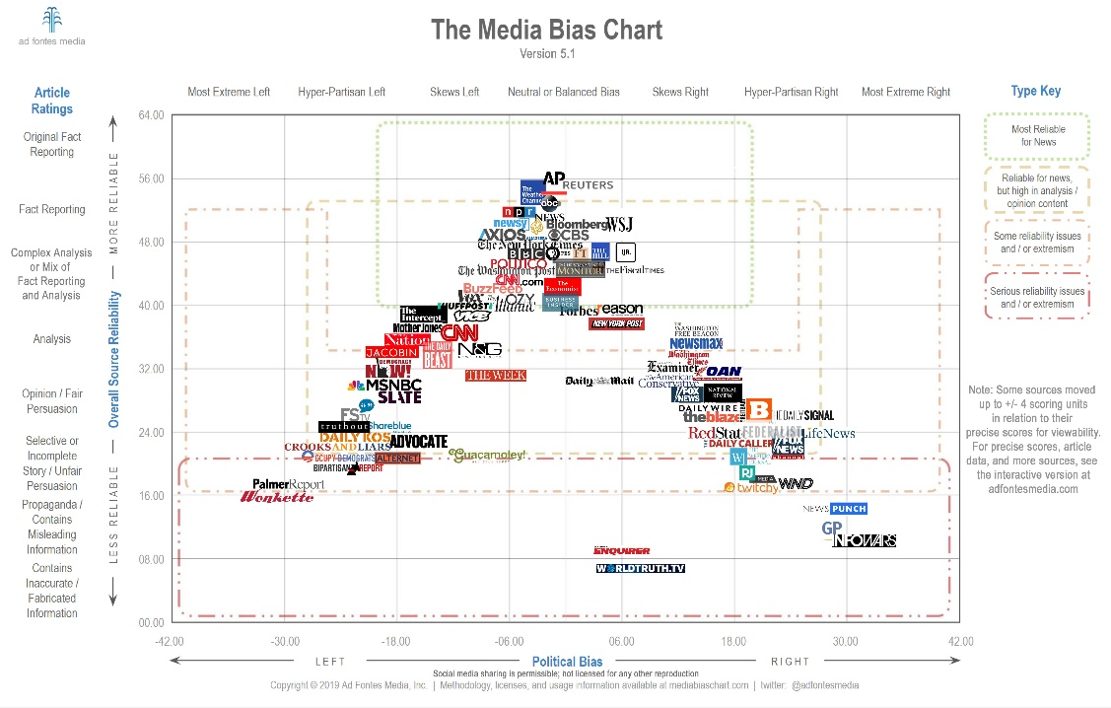
Allsides’ 2019 media bias rating:
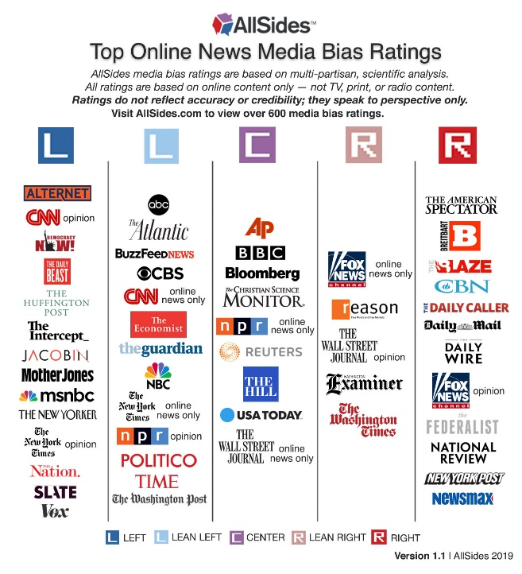
Appendix 2: Key Words for Corpus filtering
Weibo Posts in Simplified Chinese | Tweets in English | Tweets in Traditional Chinese
香港  香港人  五大诉求  付国豪  林郑月  一国两制  返送中  逃犯条例  引渡  暴乱 | Hong Kong  HK  HongKonger  HKer  香港  Five Demands  One Country, Two Systems  Carrie Lam  Fu Guohao  antiELAB  Extradition  Riot | 香港  香港人  五大訴求  付國豪  林鄭月娥  一國兩制  返送中  逃犯條例  引渡  暴亂

Appendix 3: Word Cloud Comparison
Dataset 1: Baseline vs. External Propaganda
Baseline | Propaganda
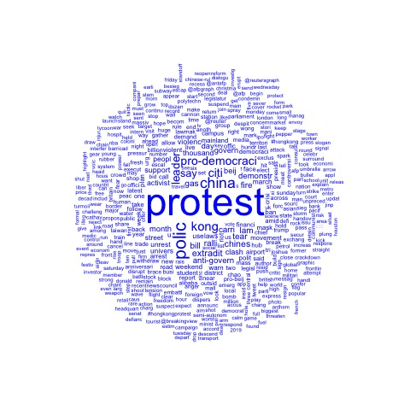 | 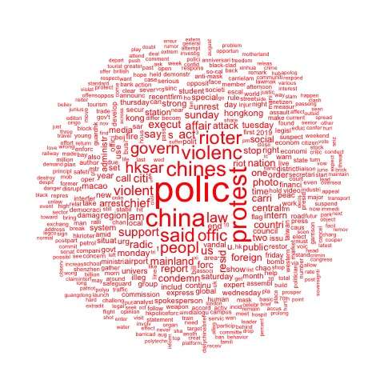
Dataset 2: Internal vs. External Propaganda (English)
Internal Propaganda | External Propaganda (English translated to Chinese)
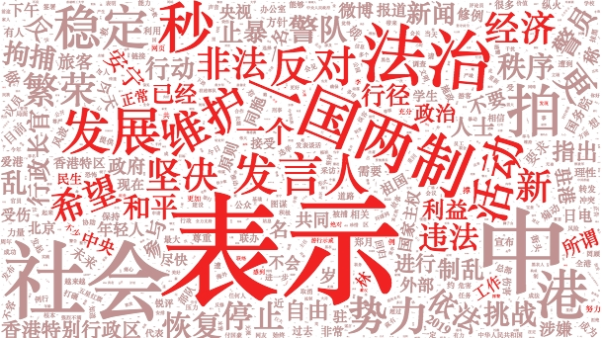 | 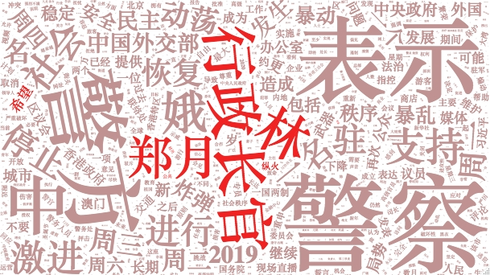
Dataset 2: Internal vs. External Propaganda (Traditional Chinese)
Internal Propaganda | External Propaganda (Traditional to Simplified Chinese)
 | 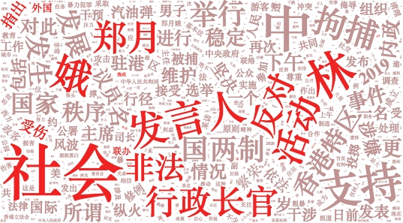

Appendix 4: Top Words for All Topics of Interest in All Three Datasets
Appendix 4.1: Dataset 1 – Baseline vs. External Propaganda in English
Topic 9 in Dataset 1
Highest Prob: | Protest | Pro-democraci | kong | leader | citi | extradit | say | ralli | Anti-govern | demonstr
FREX： | Pro-democraci | thousand | leader | extradit | Pro-beij | Anti-govern | activist | ralli | embattl | march
Lift： | Chinese-rul |  | brace | Colonia-era | converg | defiant | design | factbox | heckl | landslid
Score: | Pro-democraci | protest | extradit | leader | design | thousand | clash | Pro-beij | bill | ralli
Topic 10 in Dataset 1
Highest Prob: | Protest | report | photo | media | radic | violent | forc | support | said | Show
FREX： | photo | media | western | inform | famili | children | facebook | ic | vcg | xinhua
Lift： | catalonia | display | incit | jimmi | twitter | amazon | children | facebook | hatr | inform
Score: | photo | display | media | protest | radic | western | report | netizen | ic | violent

Appendix 4.2: Dataset 2 – Internal vs. External Propaganda in English
Topic 2 in Dataset 2
Highest Prob: | 人权 | 民主 | 法案 | 美国 | 美方 | 事务 | 干涉 | 内政 | 反对 | 发展
FREX： | 人权 | 民主 | 法案 | 签署 | 美国国会 | 成发 | 决心 | 坚定不移 | 利益 | 美国国会参议院
Lift： | 一意孤行 | 侵犯 | 副部长 | 参议院 | 美国国会参议院 | 众议院 | 召见 | 国内法 | 强烈抗议 | 成发
Score: | 法案 | 美方 | 侵犯 | 内政 | 人权 | 干涉 | 中方 | 民主 | 事务 | 成发
Topic 4 in Dataset 2
Highest Prob: | 警察 | 暴力 | 集会 | 支持 | 香港市民 | 守护 | 市民 | sir | 参加 | 国旗
FREX： | sir | 加油 | 爱 | 转发 | 自发 | 参加 | 来到 | 孩子 | 公园 | 微博
Lift： | 唱国歌 | 歌唱祖国 | 仪式 | 儿子 | 光头 | 全民 | 制作 | 加油打气 | 受邀 | 后悔
Score: | sir | 转发 | 救 | 加油 | 警察 | 守护 | 爱 | 制作 | 自发 | 孩子
Topic 6 in Dataset 2
Highest Prob: | 暴力 | 法治 | 社会 | 支持 | 表示 | 特区政府 | 维护 | 严重 | 谴责 | 市民
FREX： | 法治 | 执法 | 国徽 | 违法 | 冲击 | 联办 | 机构 | 社会秩序 | 挑战 | 底线
Lift： | 充斥 | 依法追究 | 国徽 | 污损 | 必要措施 | 支柱 | 不能容忍 | 压倒一切 | 旗帜鲜明 | 急迫
Score: | 法治 | 充斥 | 国徽 | 一国两制 | 底线 | 谴责 | 强烈 | 冲击 | 联办 | 严正
Topic 10 in Dataset 2
Highest Prob: | 港 | 暴力 | 乱 | 势力 | 分子 | 中 | 暴徒 | 人民 | 乱港 | 政治
FREX： | 锐评 | 例 | 乱港 | 乱 | 风波 | 安生 | 革命 | 黎智英 | 颜色 | 乱局
Lift： | 私利 | 黎 | 人心所向 | 信 | 充当 | 关乎 | 可谓 | 安生 | 无耻 | 柱
Score: | 信 | 势力 | 锐评 | 乱 | 乱港 | 黎智英 | 李柱铭 | 安生 | 正义 | 例

Appendix 4.3: Dataset 3 – Internal vs. External Propaganda in Traditional Chinese
Topic 2 in Dataset 3
Highest Prob: | 美国 | 事务 | 美方 | 法案 | 人权 | 民主 | 内政 | 表示 | 干涉 | 发言人
FREX： | 美方 | 法案 | 内政 | 干涉 | 外交部 | 中方 | 涉港 | 插手 | 公署 | 人权
Lift： | 内政 | 华春莹 | 强烈抗议 | 美参议院 | 耿爽 | 美方 | 中方 | 交涉 | 公署 | 召见
Score: | 美方 | 法案 | 内政 | 中方 | 外交部 | 干涉 | 事务 | 人权 | 干预 | 美国
Topic 3 in Dataset 3
Highest Prob: | 暴力 | 一国两制 | 法治 | 势力 | 底线 | 发生 | 挑战 | 中 | 西方 | 原则
FREX： | 原则 | 西方 | 底线 | 势力 | 挑战 | 背后 | 一国两制 | 激进分子 | 革命 | 践踏
Lift： | 一条 | 题 | 借口 | 触碰 | 看清 | 革命 | 一小撮 | 原则 | 背后 | 西方
Score: | 势力 | 一条 | 一国两制 | 底线 | 西方 | 法治 | 挑战 | 外部 | 原则 | 中央政府
Topic 4 in Dataset 3
Highest Prob: | 港 | 青年 | 中 | 媒体 | 学生 | 分子 | 活动 | 组织 | 风波 | 乱港
FREX： | 学生 | 慨 | 黄之锋 | 部队 | 学校 | 青年 | 教育 | 喺 | 风波 | 安生
Lift： | 众志 | 中国人民解放军 | 台 | 咗 | 开学 | 慨 | 校长 | 解放军 | 制暴 | 喺
Score: | 制暴 | 青年 | 黄之锋 | 部队 | 慨 | 安生 | 学生 | 次 | 周年 | 驻
Topic 9 in Dataset 3
Highest Prob: | 警察 | 守护 | 集会 | 香港市民 | 市民 | 支持 | 国旗 | 暴力 | 警队 | sir
FREX： | sir | 自发 | 加油 | 转发 | 爱 | 微博 | 五星红旗 | 救 | 来到 | 公园
Lift： | 警长 | sir | 加油 | 卢伟聪 | 哋 | 国歌 | 成都 | 歌曲 | 自发 | 转发
Score: | 警察 | sir | 卢伟聪 | 加油 | 自发 | 转发 | 爱 | 救 | 现场 | 唱国歌

Appendix 5: Topical Correlation
Appendix 5.1: Internal Propaganda vs. External Propaganda (English)
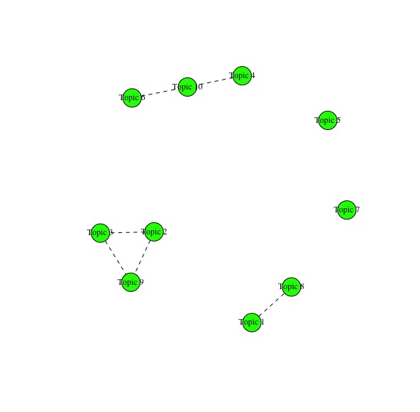
Appendix 5.2: Internal Propaganda vs. External Propaganda (Traditional Chinese)
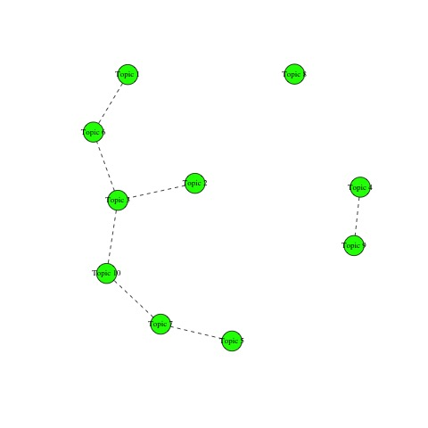

References
Acemoglu, Daron and James. A, Robinson. 2006. Economic Origins of Dictatorship and Democracy. Cambridge; New York: Cambridge University Press
Anderson, Benedict. 1983. Imagined Communities – Reflections on the Origin and Spread of Nationalism. Verso. pp.25
Carter, Erin Baggott and Carter, Brett L.. 2020. “When Autocrats Threaten Citizens With Repression: Evidence from China.” British Journal of Political Science. Forthcoming.
CCTV. 2019. “Yi Qiao Jia Qiao – Xi Jinping Zheyang Tan Qiaowu Gongzuo” (Build the Bridge with Huaqiao – This is How Xi Jinping Talks About Works on Overseas Chinese Affairs). May 29. http://news.cctv.com/2019/05/29/ARTI9uVgvrYLub6XLtIXWiW8190529.shtml
Clayton Richard, Murdoch Steven J., and Watson Robert N.M.. 2006. “Ignoring the Great Firewall of China.” In: Danezis George and Golle. 2006. Philippe Privacy Enhancing Technologies. Springer-Verlag Berlin Heidelberg
Chen, Titus C.. 2010. “China’s Reaction to the Color Revolutions: Adaptive Authoritarianism in Full Swing”. Asian Perspective, Vol. 34, No.2 (2010), pp. 5 – 51
Chen Jianxing, Wang Feng, and Zhou Wenqi. 2019. “Zhibao Zhiluan Huifu Zhixu Shi Xianggang Dangqian Yadao Yiqie De Jinji Renwu” (Stopping Violence, Controlling Chaos and Restoring Order Are the Overriding and Urgent Tasks for Hong Kong at Present). August 7. Xinhua. http://www.xinhuanet.com/2019-08/07/c_1124849007.htm
Cheung, Tony, Kang-chung Ng, and Lok-kei Sum. 2020. “Beijing’s New Envoy Urges Hong Kong Leader Carrie Lam in First Talks to Step Up Efforts to Quell Protest Unrest”. January 9. South China Morning Post. https://www.scmp.com/news/hong-kong/politics/article/3045337/beijings-new-envoy-hong-kong-holds-talks-carrie-lam
CPCNEWS. 2015. “Chongwen Xi Jinping 819 Jianghua: Xuanchuan Sixiang Bumen Bixu Shoutu Youze” (Revisit Xi Jinping’s August 19 Speech: Propaganda and Ideological Departments Must Be Responsible for Guarding the Motherland). August 19. http://cpc.people.com.cn/xuexi/n/2015/0819/c385474-27483230.html
CPCNEWS. 2016. “Xi Jinping Shibada Yilai Guanyu “Xinwen Yulun Gongzuo” Jingcai Lunshu Zhaibian” (Excerpts and Compilations of Excellent Comments on “News and Public Opinion Work” Since the 18th Party Congress). February 25. http://cpc.people.com.cn/xuexi/n1/2016/0225/c385474-28147905.html
Deng, Xiaoping. 1989. The Selective Works of Deng Xiaoping. Volume 3, pp. 303 344 and 380
Edmond, Chris. 2013. “Information Manipulation, Coordination, and Regime Change.” Review of Economic Studies 80(4):1422–1458.
Ellul, Jacques. 1965. Propaganda: The Formation of Men’s Attitudes.
Faris, Robert and Roberts, Hal and Etling, Bruce and Bourassa, Nikki and Zuckerman, Ethan and Benkler, Yochai. 2017. Partisanship, Propaganda, and Disinformation: Online Media and the 2016 U.S. Presidential Election. Berkman Klein Center Research Publication 2017-6.
Gao Qi, Abel Fabian, Houben Geert-Jan, and Yu Yong. 2012. “A Comparative Study of Users’ Microblogging Behavior on Sina Weibo and Twitter”. In: Masthoff Judith, Mobasher Bamshad, Desmarais Michel C., and Nkambou Roger. 2012. User Modeling, Adaptation, and Personalization. Springer-Verlag Berlin Heidelberg.
Hitler, Adolf. 1941. “The Art of Propaganda”. The New York Times, June 22, 1941, https://www.nytimes.com/1941/06/22/archives/the-art-of-propaganda-by-adolf-hitler.html
Hu, Jintao, 2006. The Selective Works of Hu Jintao. Volume 2, pp. 471 and 486
Huang, Haifeng. 2015. “Propaganda as Signaling.” Comparative Politics 47(4):419–444.
Jowett, Garth S. and O’Donnell, Victoria. 2018. Propaganda & Persuasion: 5th Edition. SAGE Publications: pp. 272-280
King, Gary, Jennifer Pan and Margaret E. Roberts. 2013, “How Censorship in China Allows Government Criticism but Silences Collective Expression”. American Political Science Review. Vol. 107, No.2, pp. 326 – 343
King, Gary, Jennifer Pan and Margaret E. Roberts. 2017. “How the Chinese Government Fabricates Social Media Posts for Strategic Distraction, Not Engaged Argument”. American Political Science Review. 111, 3, 484 – 501
Kuran, Timur. 1991. “Now Out of Never: The Element of Surprise in the East European Revolution of 1989”. World Politics. Vol. 44, No.1, pp. 7-48
Lamberova, Natalia & Daniel Treisman, 2020. “Putin’s Strategy After the Global Financial Crisis of 2008-9.” Economic Shocks and Authoritarian Stability. Ann Arbor MI: University of Michigan Press
Li, Yukun. 2019. “Zhao Kezhi: Fangfan Diyu “Yanse Geming”, Dahao Zhengzhi Anquan Baoweizhang” (Zhao Kezhi: Prevent and Resist the “Color Revolution” and Fight for Political Security). Beijing News. January 18. http://www.bjnews.com.cn/news/2019/01/18/540767.html
Little, Andrew T. 2017. “Propaganda and Credulity.” Games and Economic Behavior 102:224–232.
Mao, Zedong. 1929. “Hongjun Xuanchuan Gongzuo Wenti” (On the Publicity Work of the Red Army). In The Collective Works of Mao Zedong. Volume 1. People’s Publishing House. http://www.people.com.cn/GB/shizheng/8198/30446/30452/2208299.html
Marsh, Jenni. 2019. “Why Pro-Democracy Troublemaker Jimmy Lai is the Only Hong Kong Multi-Millionaire Standing Up to China”. CNN. August 28. https://www.cnn.com/2019/08/27/media/jimmy-lai-hong-kong-protests-intl-hk/index.html
Mesquita, Bruce Bueno De & Smith, Alastair. 2011. The Dictator’s Handbook. Public AffairsTM. Pp. 201
Miller, Mark Crispin. 2004. Introduction. In: Bernays, Edward. 1928, Propaganda. Routledge.
Ni, Guanghui. 2013. “Xi Jinping: Xionghuai Daju Bawo Dashi Zhuoyan Dashi, Nuli Ba Xuanchuan Sixiang Gongzuo Zuode Genghao” (Xi Jinping: Keeping in Mind the Overall Situation, Grapsing the General Trend, Focusing on Major Issues, and Striving to Do a Better Job of Propaganda and Ideological Work). People’s Daily. August 20. http://cpc.people.com.cn/n/2013/0821/c64094-22636876.html
Oliver, Pamela E. and Myers, Daniel J. 1999. “How Events Enter the Public Sphere: Conflict, Location, and Sponsorship in Local Newspaper Coverage of Public Events”. American Journal of Sociology. Pp 38 – 87.
People’s Daily. 2015. “Zhongguo Gongchandang Tongyi Zhanxian Gongzuotiaoli (Shixing)” (Interim Regulation on the Communist Party of China’s United Front Work). September 23. http://cpc.people.com.cn/n/2015/0923/c64107-27622040.html
Qiushi. 2018. “Xi Jinping Ruhe Zhidao Xuanchuan Sixiang Gongzuo” (How Does Xi Jinping Guide Propaganda and Ideological Work). July 6. http://news.cctv.com/2018/07/06/ARTIbNfVxsqai6e93pBQ7xnD180706.shtml Xi gave the speech at a symposium on news and public opinion work on February 19, 2016
Roberts, Margaret and Stewart, Brandon and Tingley, Dustin. 2019. “stm: An R Package for Structural Topic Models”. Journal of Statistical Software. 91:2.
Rozenas, Arturas and Denis Stukal. 2019. “How Autocrats Manipulate Economic News: Evidence from Russia’s State-Controlled Television.” Journal of Politics, 81:3, 982-996.
Saussy, Haun. 2001. Great Walls of Discourse and Other Adventures in Cultural China. Harvard University Asia Center. Pp. 237
Singh, Karishma, Jim Clare, Birsel Robert, Richardson Alex, and Tait Paul. 2019. “Timeline: Key Dates in Hong Kong’s Anti-Government Protests”. Reuters. November 10. https://www.reuters.com/article/us-hongkong-protests-timeline/timeline-key-dates-in-hong-kongs-anti-government-protests-idUSKBN1XL0N3
Stanley, Jason. 2015. How Propaganda Works, Princeton; Oxford: Princeton University Press: pp. 162 and pp. 223 – 268
Treisman, Daniel, and Sergei Guriev. 2019. “Informational Autocrat.” Journal of Economic Perspectives 33(4): 100 – 27
Van Vleet, Jacob E. & Rollison, Jacob Marques. 2020. Jacques Ellul: A Companion to His Major Works. Cascade Books.
Weiss, Jessica Chen. 2013. “Authoritarian Signaling, Mass Audiences, and Nationalist Protest in China”. International Organization. 67(1), 1-35.
Wen-Hsuan Tsai (2017) Enabling China’s Voice to Be Heard by the World: Ideas and Operations of the Chinese Communist Party’s External Propaganda System, Problems of Post-Communism, 64:3-4, 203-213.
Xi, Jinping. 1995. “Daqiaowu Guannian De Queli” (The Establishment of the Concept of ‘Big Overseas Chinese Affairs’). February 1995. Strategy and Management. Pp.111.
Xi, Jinping. 2015. “Speech at the Central United Front Work Conference”. In Excerpts from the Discussion on Socialist Political Construction. Central literature Publishing House. Pp. 18.
Xi, Zhongxun. 1984. “Comrade Xi Zhongxun’s Speech at the Meeting with Directors of Overseas Chinese Affairs Office at the Provincial Level, Autonomous Region Level, and the Level of the Municipalities Under the Jurisdiction of the Central Government”, included in the internal document Compilation of Regulations on Overseas Chinese Affairs compiled by the Overseas Chinese Affairs Office of the State Council, pg.23-24, 1997. Quoted in Zhuang Guotu, “Changes in Chinese Government’s Attitudes and Policies Towards Huaqiao and Huaren since 1978”, Third issue of Research on Southeast Asian Issues in 2000, pg 5.
Xinhua. 2016. “Zhonggong Zhongyang Bangongting Yinfa Zhongguo Qiaolian Gaige Fangan” (The General Office of the CCP Central Committee Issues the Reform Plan for All-China Federation of Returned Overseas Chinese). December 4. http://www.gov.cn/xinwen/2016-12/04/content_5142958.htm
Xinhua. 2019. “’Huogang Sirenbang’ Tianxinzui: Panguo” (“Gang of Four” Who Wrecked Havoc in Hong Kong Commit New Crime: Treason!) August 30. http://www.xinhuanet.com/gangao/2019-08/30/c_1210262880.htm
Xinhua. 2019. “Tuidong Meiti Ronghe Xiang Zongshen Fazhan, Gonggu Quandang Quanguo Renmin Gongtong Sixiang Jichu” (Promoting Media Convergence to Develop in Depth and Consolidate the Common Ideological Foundation of the Whole Party and People). January 25. http://www.xinhuanet.com/politics/leaders/2019-01/25/c_1124044208.htm
Xinhua. 2019. “Zhonggong Zhongyang Guanyu Jianchi He Wanshan Zhongguo Tese Shehuizhuyi Zhidu Tuijin Guojia Zhili Tixi He Zhili Nengli Xiandaihua Ruogan Zhongda Wenti De Jueding” (The CCP Central Committee on Adhering to and Perfecting the Socialist System with Chinese Characteristics Decision on Several Major Issues of Promoting Modernization). November 5th. http://www.xinhuanet.com/politics/2019-11/05/c_1125195786.htm
Yang, Weihan and Wang Qi. 2019. “Xi Jinping Zai Quanguo Minzu Tuanjie Jinbu Biaozhang Dahuishang Fabiao Zhongyao Jianghua” (Xi Jinping Delivers Important Speech at the National Congress for Recognition and Reward of National Unity and Progress). Xinhua. September 27. http://www.xinhuanet.com/politics/leaders/2019-09/27/c_1125048317.htm
Zhai, Keith, Pomfret James, and Kirton David. 2019. “Exclusive: China Sets Up Hong Kong Crisis Center in Mainland, Considers Replacing Chief Liaison”. Reuters. November 25. https://www.reuters.com/article/us-hongkong-protests-shenzhen-exclusive/exclusive-china-sets-up-hong-kong-crisis-center-in-mainland-considers-replacing-chief-liaison-idUSKBN1Y000P
Zhang, Xiaosong and Huang, Xiaoxi. 2018. “Xi Jinping Chuxi Quanguo Xuanchuan Sixiang Gongzuo Huiyi Bing Fabiao Jianghua” (Xi Jinping Attended the National Conference on Propaganda and Ideological Work and Delivered a Speech). Xinhua. August 22. http://www.xinhuanet.com/2018-08/23/c_129938245.htm
Zhao, Suisheng. 2004. A Nation-State by Construction: Dynamics of Modern Chinese Nationalism. Stanford University Press.
Zhuang, Pinghui. 2016. “China’s Top Party Mouthpieces Pledge ‘Absolute Loyalty’ as President Makes Rare Visits to Newsrooms”. February 19. https://www.scmp.com/news/china/policies-politics/article/1914136/chinas-top-party-mouthpieces-pledge-absolute-loyalty

A couple of examples include Georgia’s Rose Revolution in 2003, Ukraine’s Orange Revolution in 2004, and Kyrgyzstan’s Tulip Revolution in 2005
These three agencies are the only three China’s state media that have verified active presence on both Weibo and Twitter. Some of them also have verified accounts tweeting in foreign language other than English, such as German, Russian, Latin etc. Due to the limit of capacity, this paper will only compare content in English and traditional Chinese with simplified Chinese. Future work should also including other foreign language to see if there is more variation in China’s external propaganda.
This paper chooses March 31st, 2019 as the starting date because it was reportedly the earliest date when Hong Kong citizens gathered in large scale to protest against the city government’s proposed amendments to the extradition law in February. The protest on that date could hence be interpreted as the first response from Hong Kong people to the amendments and the beginning of subsequent months of protests. The paper chooses January 9th as the end date because of its symbolic meaning. After the pro-establishment side lost in the district election in Hong Kong in a landslide in November last year, there were media reports suggesting that Beijing was not happy about the way the HK and Macau Affairs Office, represented by Zhang Xiaoming at the time, gathered intelligence on the ground in Hong Kong. Some even went a step further by suggesting that these intel, which was largely collected based on the response from the upper-class society in the city, greatly misled the party central in terms of judging what was happening in Hong Kong. The replacement of Zhang Xiaoming with Luo Huining, therefore, suggests a change in the Party’s policy towards Hong Kong and Macau affairs. Since January 9th is the date when Luo Huining, the newly appointed director of the HK and Macau Office, had his first meeting with Carrie Lam and the propaganda cycle regarding the outbreak of the coronavirus began, this paper considers it as the end point for the central government’s policy change towards Hong Kong and the propaganda campaign against the protests (Zhai, et al., 2019).
See Appendix 2 for the list of words used for filtering.
For baseline comparison only, the propaganda group also includes Global Times’s verified English account on Twitter
See Appendix 1 for examples
The order of topics across all three datasets do not matter.
“Highest Prob” refers to words used the most frequently in the topic.
“FREX” weights words by their overall frequency and how exclusive they are to the topic.
“Lift” weights words by dividing by their frequency in other topics, therefore giving higher weight to words that appear less frequently in other topics.
“Score” divides the log frequency of the word in the topic by the log frequency of the word in other topics.
Source: https://www.adfontesmedia.com/static-mbc/?v=402f03a963ba
Source: https://www.allsides.com/media-bias/media-bias-chart

