“I Still Believe in Our City”
Social Media Toolkit
In 2020, as COVID-19 flared through NYC and city hospitals saw a spike of nearly 200,000 patients, Asian and Pacific Islander (API) communities faced an added threat: blame, racism, and xenophobia.
From February through July, the NYC Commission on Human Rights recorded 184 incidents of anti-Asian discrimination, harassment, or bias, representing a nearly 7-fold increase from the same period the previous year (26).
In response to this increase in anti-Asian discrimination and harassment, the Commission partnered with one of its Public Artists in Residence, Amanda Phingbodhipakkiya, to develop a public education initiative as a testament to the beauty and resilience of New York City’s API and Black communities. Read more about the public art campaign here.
We encourage everyone to participate in this campaign by sharing social media content using the hashtag #OurCityNYC and making use of the campaign creative, available for download here. Below are content suggestions to help craft your messaging, along with some example posts. Please reach out to Max Wollner (mwollner@cchr.nyc.gov) if you have any questions!
Recommended Content Suggestions:
- Content sharing why you/your organization still believes in New York City
- Content that speaks to a rise in anti-Asian discrimination since the start of the COVID-19 pandemic.
- Content about how NYC’s API communities have persevered through this bias and hate and have continued to support New York City and its people.
- Content condemning the bias and hate API and Black communities have faced during the COVID-19 pandemic and amplifying the importance of solidarity during an unprecedented time.
- Content showing that NYC’s API communities care about their City and they will not be villainized or victimized for the perception that they are catching and spreading COVID-19.
- Content celebrating the resiliency of NYC’s API and Black communities

Social Media Handles
 | Twitter | Instagram
Amanda Phingbodhipakkiya | @alonglastname | /alonglastname
NYC Commission on Human Rights | @NYCCHR | /nycchr
NYC Department of Cultural Affairs | @NYCulture | /nyculture
Sample Posts
Example Posts | Creative Options (More in toolkit)
In the wake of the racial injustice that Black and Asian and Pacific Islanders have faced during COVID-19, #OurCityNYC affirms that Black lives matter and that API communities deserve a voice. We stand in solidarity with them as we rebuild our future. https://www.istillbelieve.nyc/about | 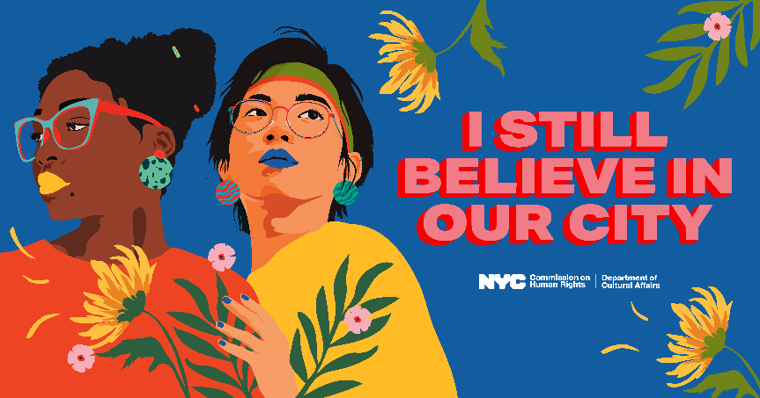
#OurCityNYC celebrates the resilience of NYC’s Black and Asian and Pacific Islander communities. NYC is only as strong as its people, and we chose to believe in our City when others did not. Learn more: https://www.istillbelieve.nyc/about | 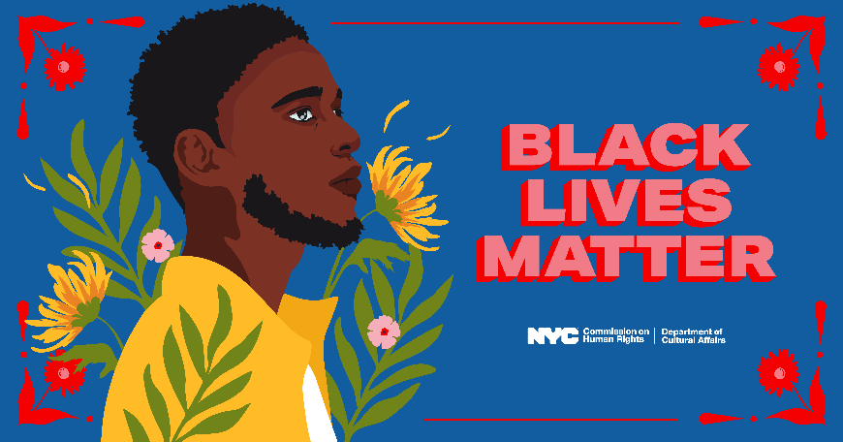  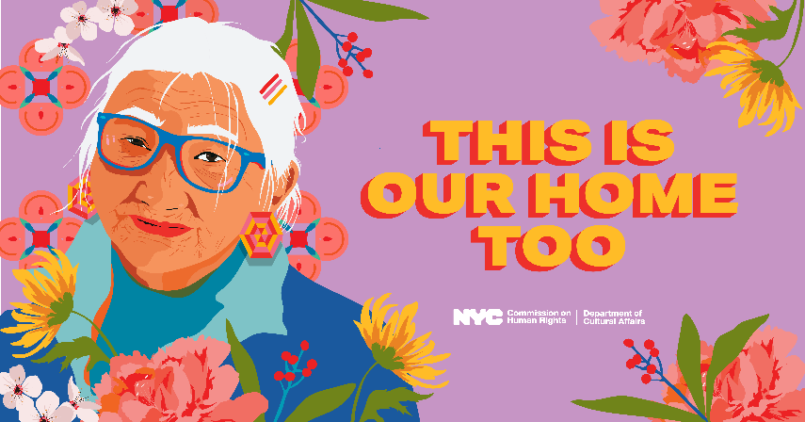
As COVID-19 hit NYC, Asian and Pacific Islanders faced an added threat: racism and hate. This powerful art campaign with @alonglastname shows the resilience of API communities and serves as a reminder that NYC is only as strong as its people. [------Insert link-----] #OurCityNYC | 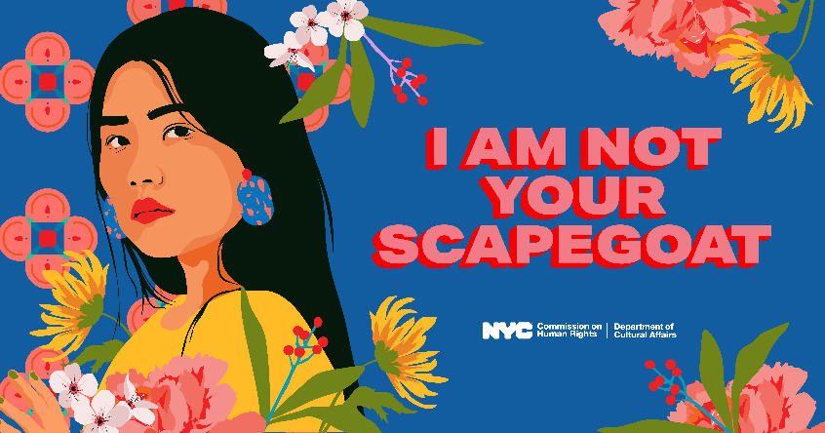  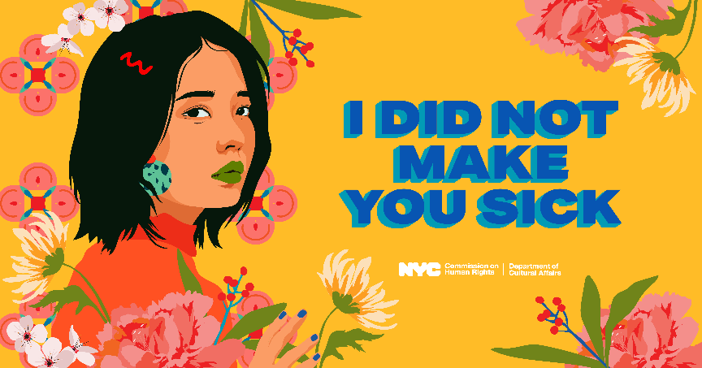  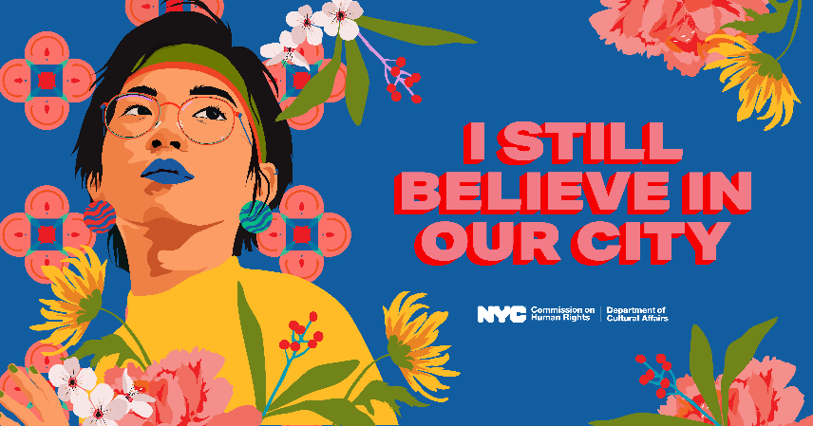  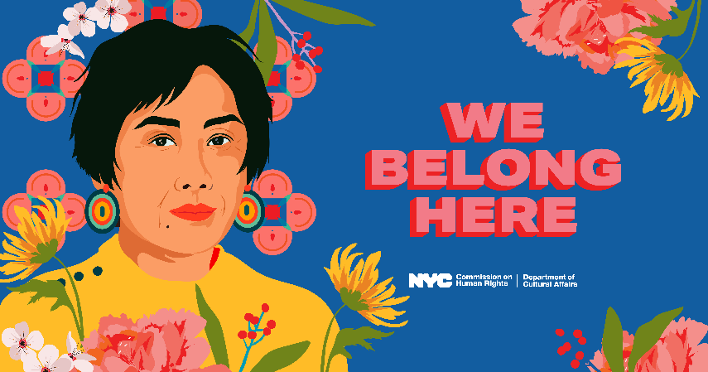
Even while facing heightened levels of discrimination and racism this year, New York’s Black and Asian and Pacific Islander communities never gave up on our city. Share why you still believe in NYC here: https://www.istillbelieve.nyc/submit

