International Human Rights Day
Social Media Toolkit
Short link for sharing: on.nyc.gov/HumanRightsDay
Every year on December 10, the world celebrates Human Rights Day, the very day when, in 1948, the United Nations General Assembly adopted the Universal Declaration of Human Rights.
The theme for this year’s Human Rights Day relates to the COVID-19 pandemic and focuses on the need to Recover Better by ensuring human rights are at the heart of the recovery efforts.
The global COVID-19 crisis has been fueled by deepening poverty, rising inequalities, structural and entrenched discrimination and other gaps in human rights protection. Only measures to close these gaps and advance human rights can ensure we fully recover to a world that is better and more resilient, just and sustainable.
Human Rights Day is an opportunity to reaffirm the importance of human rights in re-building the world we want, with global solidarity, interconnectedness and shared humanity.
About the artwork: Earlier this year, the NYC Commission on Human Rights partnered with one of its Public Artists in Residence, Amanda Phingbodhipakkiya (@alonglastname), to develop a public awareness campaign as a testament to the beauty and resilience of New York City’s Asian and Pacific Islander and Black communities. Read more about the public awareness campaign here.
Please use the hashtag #HumanRightsDay and #PAIRnyc in your posts, and tag @alonglastname, @NYCCHR, @NYCulture, and @NYCimmigrants in the photo if possible so we can help amplify!
Example Posts
Every community in NYC is different, and every one of them belongs. This #HumanRightsDay, we stand with our Black and Asian and Pacific Islander neighbors against discrimination as we work for a more inclusive NYC. #PAIRnyc | 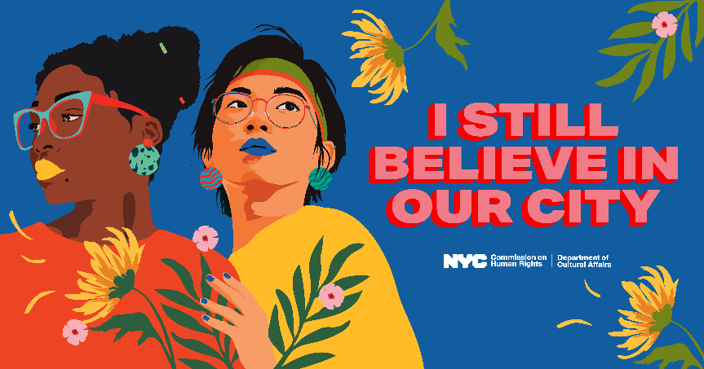  Download as a square and rectangle (Twitter) size.
The #COVID19 crisis has revealed deeply entrenched inequalities, rising poverty, and discrimination.  We must close these gaps, advance human rights, and create a more just and more resilient world. #HumanRightsDay #PAIRnyc | 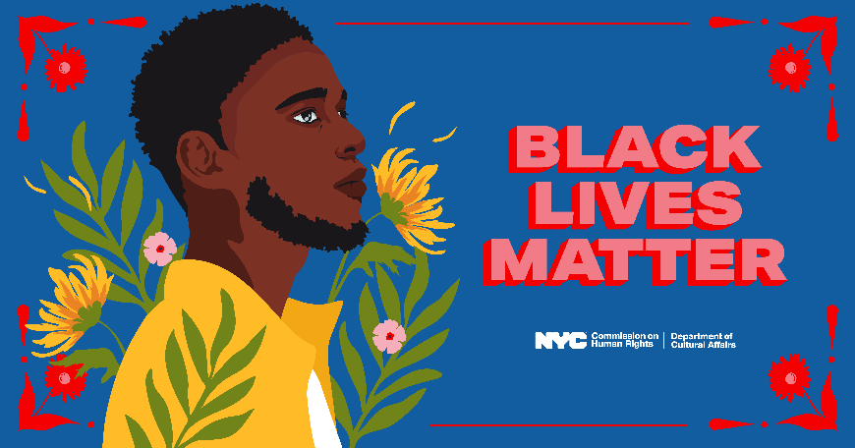  Download as a square and rectangle (Twitter) size.
No matter where you're from, what language you speak, or your immigration status -- you are a New Yorker. #HumanRightsDay #PAIRnyc | 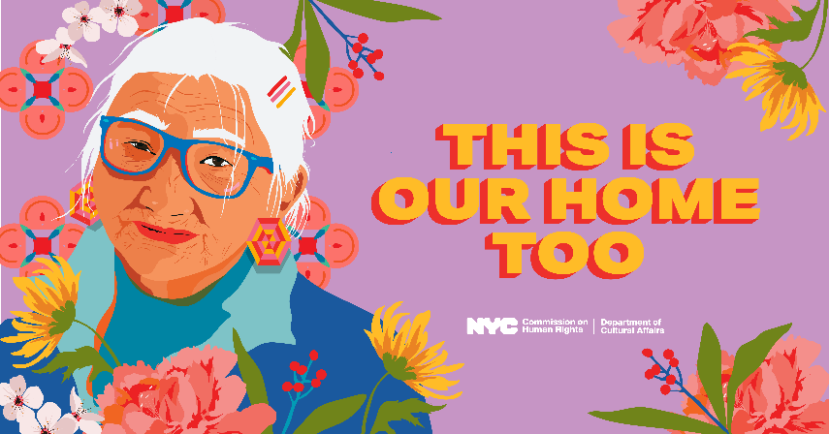  Download as a square and rectangle (Twitter) size.
As #COVID19 hit NYC, Asian and Pacific Islanders faced an added threat: racism and hate.  You have a right to live free of discrimination. Always. #HumanRightsDay #PAIRnyc | 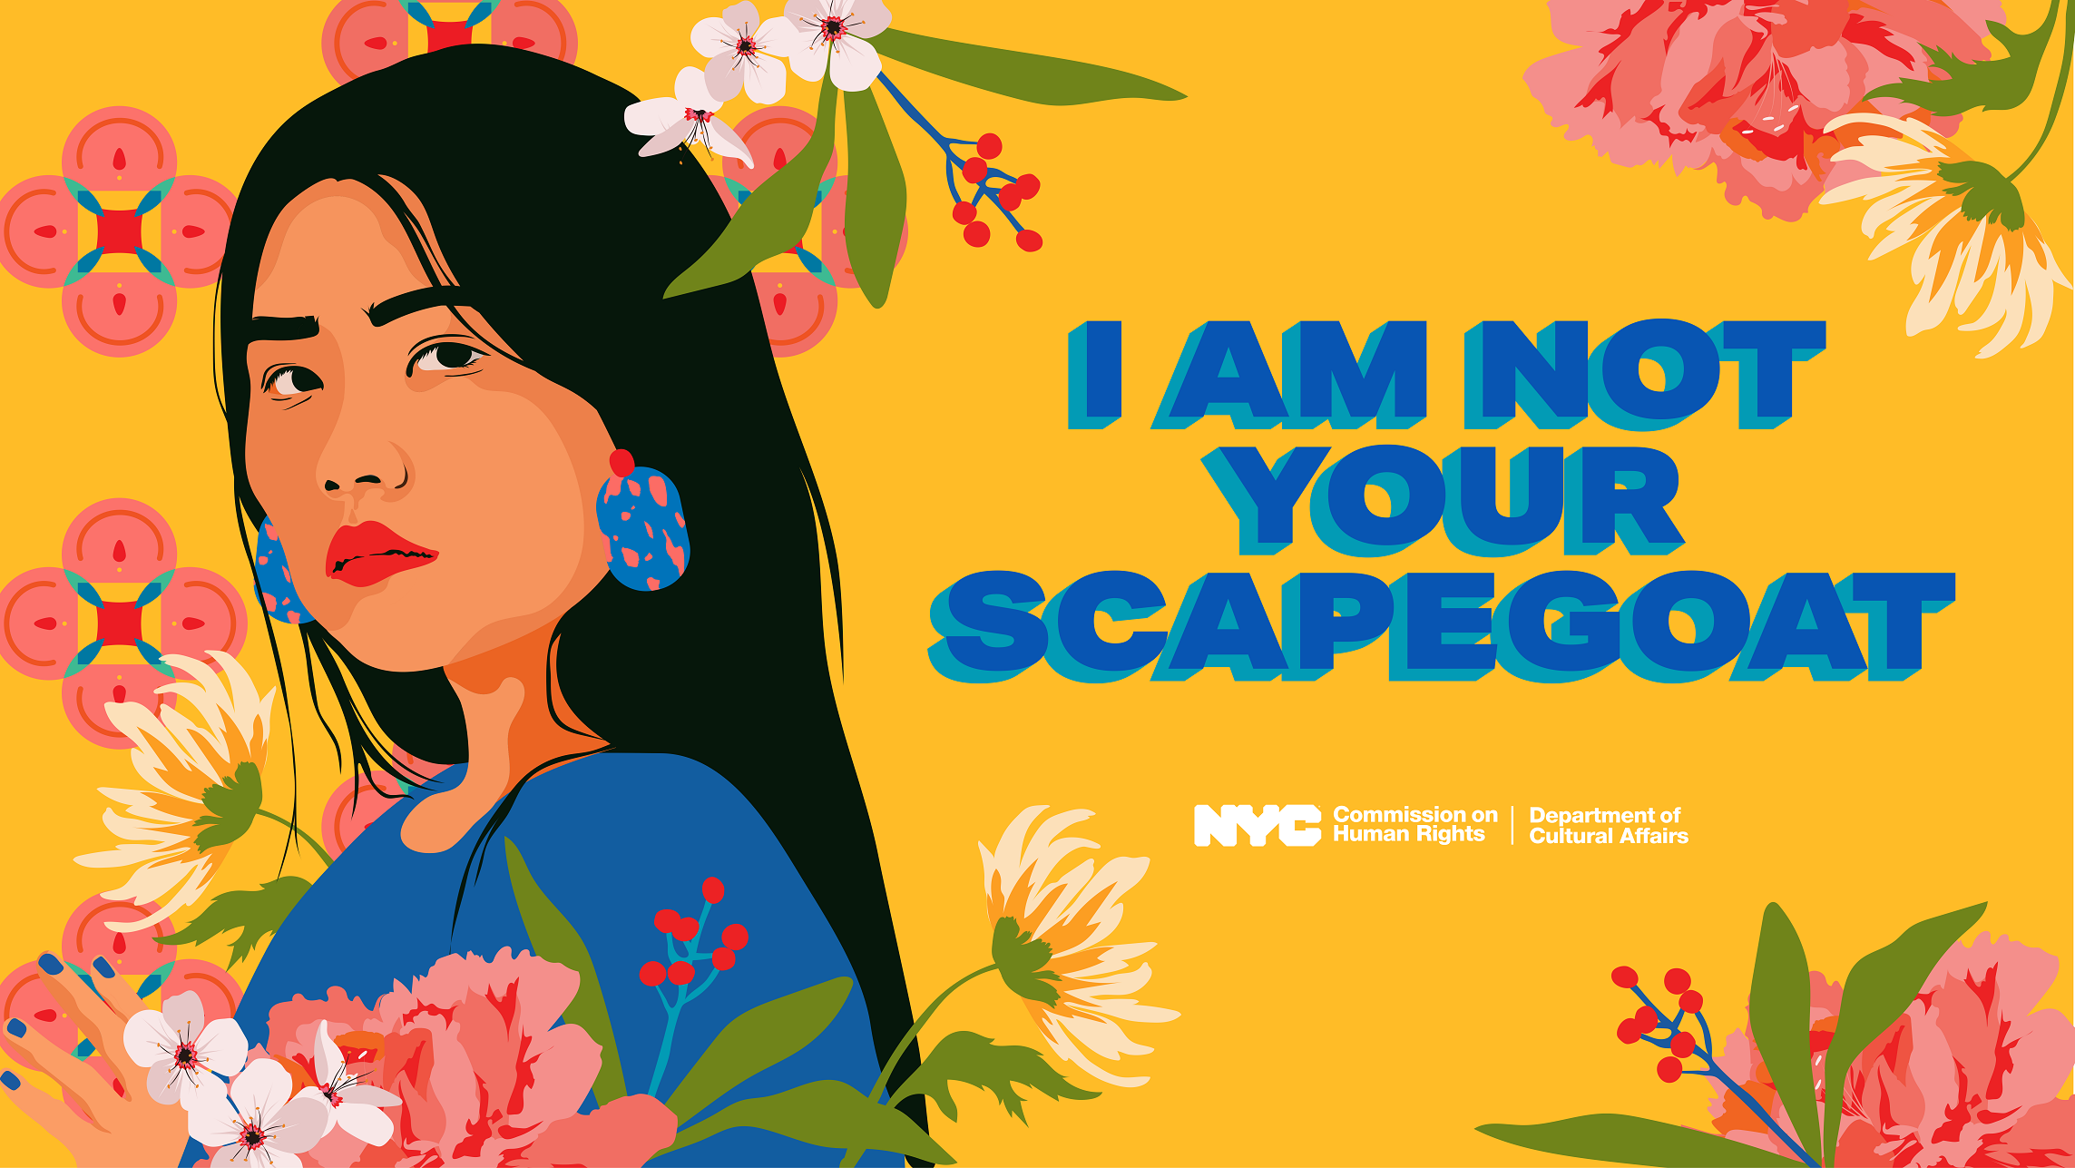  Download as a square and rectangle (Twitter) size.
If you’re here, you’re a New Yorker. And when New Yorkers come together, nothing can stop us. Let’s build a more resilient and just city — for all of us. #HumanRightsDay #PAIRnyc | 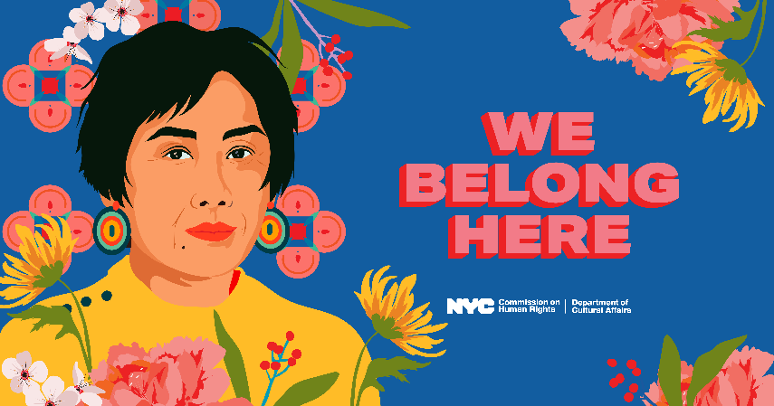  Download as a square and rectangle (Twitter) size.

