What's in a Virus’ Name? From the “China Virus” to Anti-Asian Racial Animus

Sophie Sheng and Runjing Lu

In a news conference on March 18, 2020, a reporter questioned then-President Trump on his use of the term “China Virus.” In asking that question, the reporter intended to draw attention to the increase in incidents of anti-Asian bias and violence as the pandemic spread across the United States.

Reports of anti-Asian hate and violence have grown sharply since the start of the pandemic. According to data from the Asian Pacific Policy and Planning Council, hate incidents spiked in March 2020. In January 2021, President Biden issued a presidential memorandum condemning racism, xenophobia, and intolerance against Asians and Pacific Islanders in the United States.

How does a pandemic that affects everyone trigger racial animus against a particular group? More specifically, what is the effect of COVID-19 on Americans’ attitudes towards Asians living in the United States? Could the mere association of the disease with an ethnic group cause an increase in the incidents of hate and bias against that group?

In this blogpost, we tackle the question of how to measure racial animus and investigate its relationship with hate crimes.
In our recent paper, we measure racial animus against Asians in the United States by focusing on the use of the c-word (“chink” or “chinks”) in Google searches and tweets, which accounts for both hidden and public animus. The c-word is the most salient and unambiguously pejorative racial slur against Asians in the United States. Google searches and tweets that include the epithet are mostly negative. For instance, the phrases “chinked eye” and “chink virus” are commonly found in Google queries and tweets that contain the c-word. We show that Google search volume is a good proxy for measuring racial animus using data before the analysis sample. Before the pandemic, an area’s monthly Google searches for the epithet are positively correlated with monthly anti-Asian hate crimes, and negatively correlated with monthly visits to the Chinese restaurants.

First Local COVID-19 Diagnosis Leads to a Surge in Racial Animus Against Asians

In order to estimate the causal effect of COVID-19 on racial attitudes, our study leverages different timing of the first COVID-19 diagnosis in each local area to design a quasi-random experiment.
Our results show that the pandemic led to a surge in racial animus against Asians. In the week after the first local COVID-19 diagnosis, an area’s racially charged Google search rate increased by 22.6 percent. An area’s racially charged Twitter post rate increased by 130 percent. The rate of racially charged searches and tweets decreased only slightly over the following weeks. Based on what we know about the links between racially charged online content and hate crimes, we estimate that, given the correlation based on historical data, the increase in racially charged Google search rates would imply an 8.5 percent increase in anti-Asian hate crimes in the absence of stay-at-home orders in the first month after the first local diagnosis.
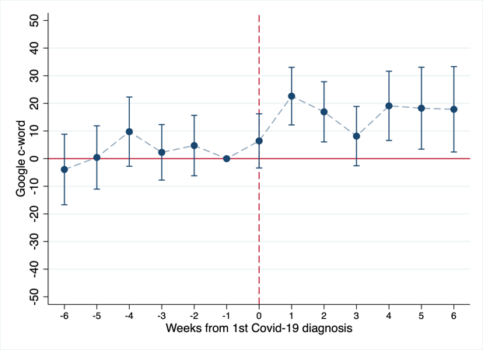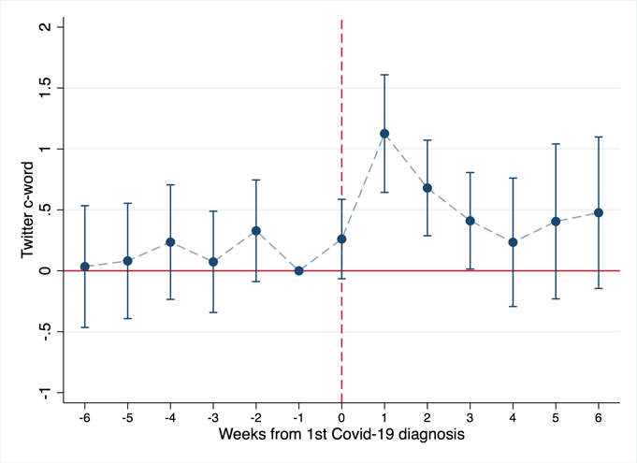
(Embed first figure here, “The Effect of the First Local COVID-19 Diagnosis on Local Racial Animus Rescaled Google Search Index”; Left: Google, Right: Twitter; the numbers are found in excel file Table 1)

A Sharp Increase in First-time Racial Epithet Users Indicates a Real Attitudinal Change Toward Asians

We also find evidence that the observed effect represents a real change in attitude towards Asians. The increase in racially charged tweets mainly comes from existing Twitter users who post racial epithets for the first time, rather than users who have previously used the term. Evidence also shows that hate incidents spiked in March 2020, and the proportion of c-word tweets tagged with anger and disgust increased from 23.3 to 40.8 percent after the first local diagnosis. Combined, they suggest that there is a change in racial attitudes, rather than a change in social norms that is more accepting expressions of racial animus.
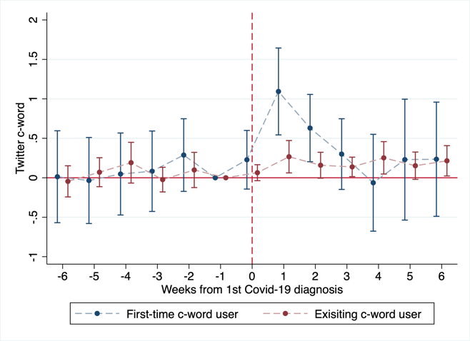
(Embed Figure 2, “The Effect of the First Local COVID-19 Diagnosis on Racially Charged Tweets by First-time and Existing C-word Users”. The numbers are attached in the email attachment named Table 2)

Words Matter More Than a Bad Economy in Foreshadowing Hate Speech and Incidents of Bias

COVID-19 takes a toll not only on lives, but also on livelihoods. Could it be that the increase in racial or ethnic animus originated from the economic downturn? Our study finds little evidence to support this hypothesis. Areas with more severe economic damage from the pandemic do not exhibit a larger increase in racial animus than areas with less severe impact.

Rather, our study finds that the key driver of anti-Asian incidents is the salience of the connection between COVID-19 and the Asian population. Using President Trump’s simultaneous mentioning of COVID-19 and China as a proxy for the salience of the connection, we found that one additional China-and-COVID tweet of President Trump corresponded to 20 percent more racially charged tweets nationwide in the four hours afterwards. Notably, we also found that one additional such tweet corresponded to an eight percentage point increase in offline anti-Asian hate incidents nationwide on the same day.

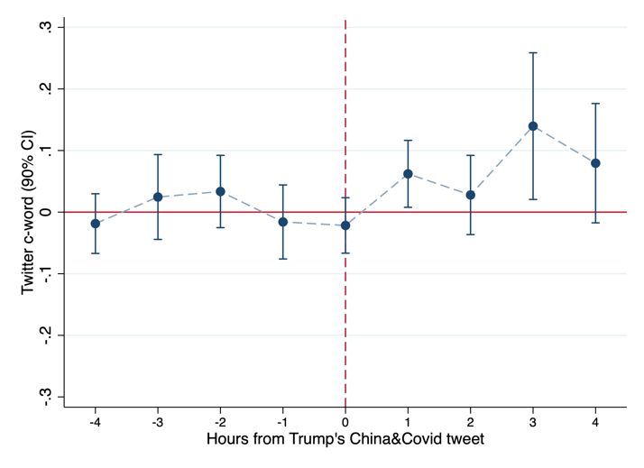
(Embed Figure 3, “Hourly Relationship between Racial Animus and President Trump’s Tweets ”, The numbers are attached in the email attachment named Table 3 )

Taken together, the salience of the connection between the disease and the Asian population has played a larger role than the negative economic impact of the disease in motivating racial animus during the pandemic. The results suggest that educating the public about the pandemic’s spread while refuting any purported connection between the disease and a particular racial or ethnic group can be effective in curbing racial animus.
Reference:
Lu, Runjing and Sheng, Yanying (Sophie), From Fear to Hate: How A Pandemic Sparks Racial Animus in the United States (July 9, 2020). 21st Century China Center Research Paper, Available at SSRN: https://ssrn.com/abstract=3646880 or http://dx.doi.org/10.2139/ssrn.3646880

