U.S. Congressional Tweets Project

At this tenuous juncture in the U.S.-China relationship, empirical understanding of Chinese favorability among Americans is of the utmost importance. While the opinions of the U.S. public are well-reflected in frequent opinion polls conducted by polling and academics centers, similar queries of U.S. elite opinion are infeasible through traditional survey methods. Congressional opinion is especially consequential due to Members of Congress being both policymakers and leaders in public discourse.
Enter the U.S. Congressional Tweets project: an ongoing 21st Century China Center endeavor to generate and monitor measures of Congressional opinion towards China through Tweets by members of congress. We hope to benchmark the current state of congressional opinion towards China in relation to previous periods and extending into the future.
We gather approximately 3,500 China-related tweets by current Senators and Representatives dating back to 2008. To contextualize the opinion measures we develop, 1,000 Congressional tweets related to Iran and 1,000 tweets related to Canada are also analyzed. Does U.S. congressional opinion about China as expressed on Twitter align more closely with opinion of an ally and partner such as Canada? Or does it instead mirror views of a country such as Iran, which has received widespread condemnation in the U.S. political arena? What issues are most salient to American national policymakers?

Sentiment Classification
To engineer a measure of congressional “sentiment” towards China similar to polling-generated favorability ratings, we classify the polarity of each tweet towards China, Iran, or Canada on a scale from “1” (very negative) to “5” (very positive). We then compute a polarity index. Classification by human “hand-coders” is utilized at this stage to ensure maximum accuracy. For future iterations, we are exploring the viability of supervised machine-learning classification algorithms.
Topic Modeling
Using a statistical topic modeling process, we identify major topics of discourse within our dataset of tweets. The four dominant topics that we will discuss here, by order of greatest prevalence, are “Trade”, “Human Rights/Advocacy”, “Security”, and “Global Governance”.

Initial Findings

#1: Tweets about China are similar to tweets about Iran – they are almost entirely negative.
In terms of aggregate sentiment, we find the polarity score of congressional tweets about China (1.56) to be statistically analogous to tweets about Iran (1.59). Very few of the 3,500 China-related tweets carried a majority-positive connotation. Comparatively, sentiment polarity of tweets about Canada was far more positive (3.99) and trends upward.
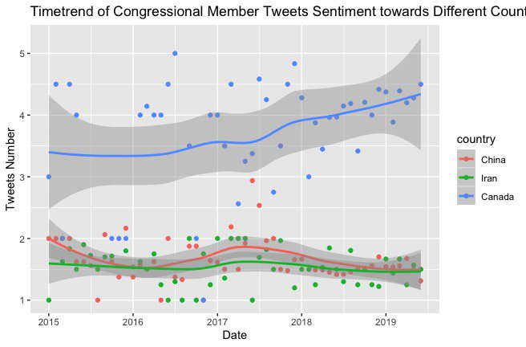

#2: Democrats and Republican Twitter sentiment on China are similar in aggregate but exhibits vastly different trends.
While Democratic sentiment towards China has been steadily declining since 2015, Republican sentiment has been far more cyclical. However, opinion has converged starting around mid-2018.
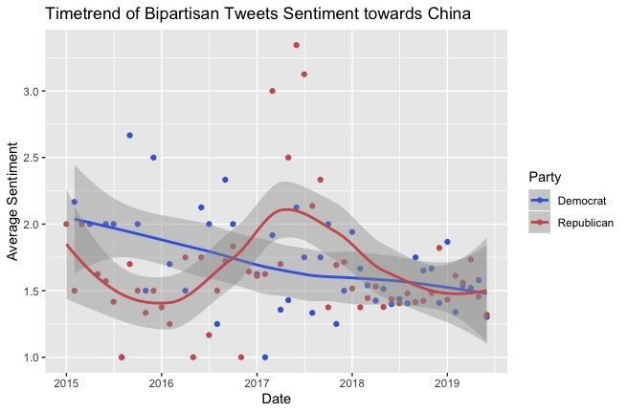

#3- Discussion of trade, human rights, and national security dominate recent Twitter discourse.
In the last few years, the prevalence of “Trade”, “Human Rights/Advocacy”, and “National Security” topics has remained relatively consistent even as sentiment levels have fluctuated within our dataset of tweets about China, Iran, and Canada. “National Security” tweets about China generally reference the hard and soft power threats China poses alongside other “bad actors” like Russia. “Human Rights” tweets overwhelmingly refer to the historical events of Tiananmen Square or more recent incidents of Chinese domestic repression. Tweets about “Trade” mention U.S.-China tariffs, trade competitiveness, and other evaluations of the bilateral trade relationship.

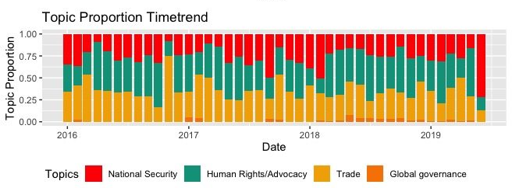

The 21st Century China Center will be releasing an interactive Congressional Tweets dashboard in the near future, which will be updated at regular intervals.

