Interpersonal Expression of Anti-Foreign Sentiment:
Evidence from a Parallel Survey in the US and China
Sichen Li and Weiyi Shi
Anti-China sentiment is on the rise around the world. In our work, we explore the dynamics of interpersonal expression of anti-foreign sentiment by leveraging a parallel survey conducted simultaneously in the US and China. We set out to answer a critical question: would providing people a more humanizing frame of reference create more favorable views of another country? Our research answers this question firmly in the affirmative, showing that both American and Chinese respondents look at one another more favorably when they view one another not just as an abstract country, but as human beings.
First, let’s describe how we created this more humanizing frame for viewing international relations. We mimicked the setting of interpersonal contact by manipulating the subjects’ perception of the environment where they filled out the survey. In the four treatment groups, respondents were informed that they were participating in a parallel survey, conducted simultaneously in the US and China, and that they had been paired with a counterpart in the other country. By telling research subjects that they had an actual human partner, we simulated a key feature of interpersonal contact: subjects were suddenly connected with a counterpart in a foreign country, not an abstract, dehumanized entity.
We thus divided our participants into four experimental groups. In the control group, respondents were asked to express their feelings toward the other country directly and were not told they had a counterpart. In the interaction group, they were told they had a counterpart who could see their answer before the counterpart answered. In the humanization group, they were given personal details about the counterpart and were aware that their answers would be viewed by the latter. In the reciprocity groups, they were randomly told that their partner had negative or positive feelings about the respondent’s country.

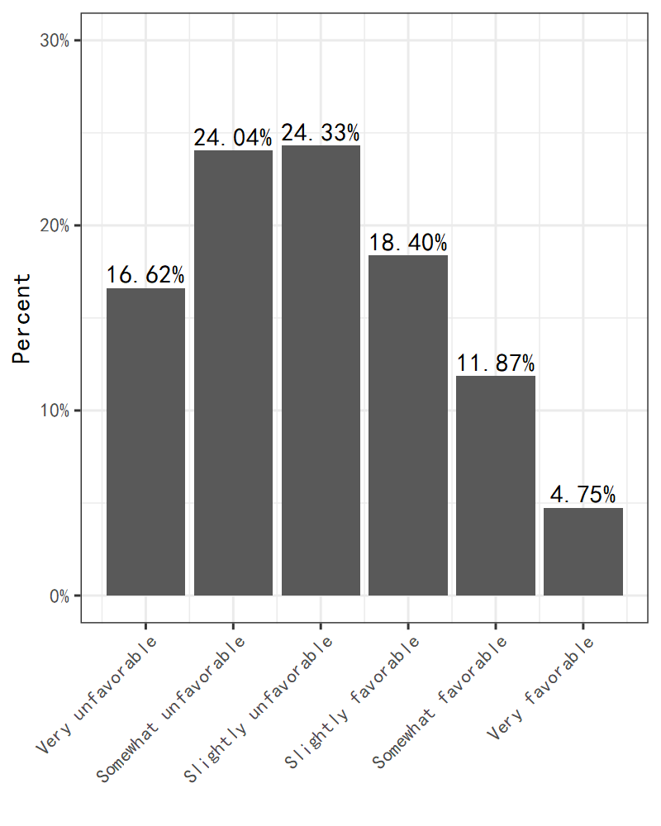
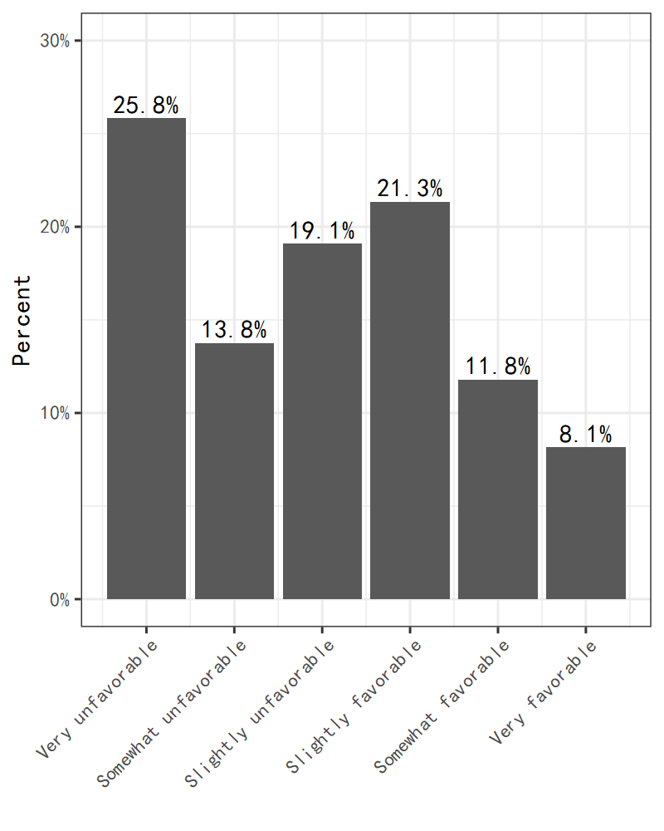

1）The Chinese sample 2) The U.S. sample
Figure 1 Anti-foreign sentiment in the control group
You can see in the graph above that, in the control group, about 65% of the Chinese respondents expressed an unfavorable view towards the U.S., with around 59% of U.S. respondents holding a similarly negative view about China.
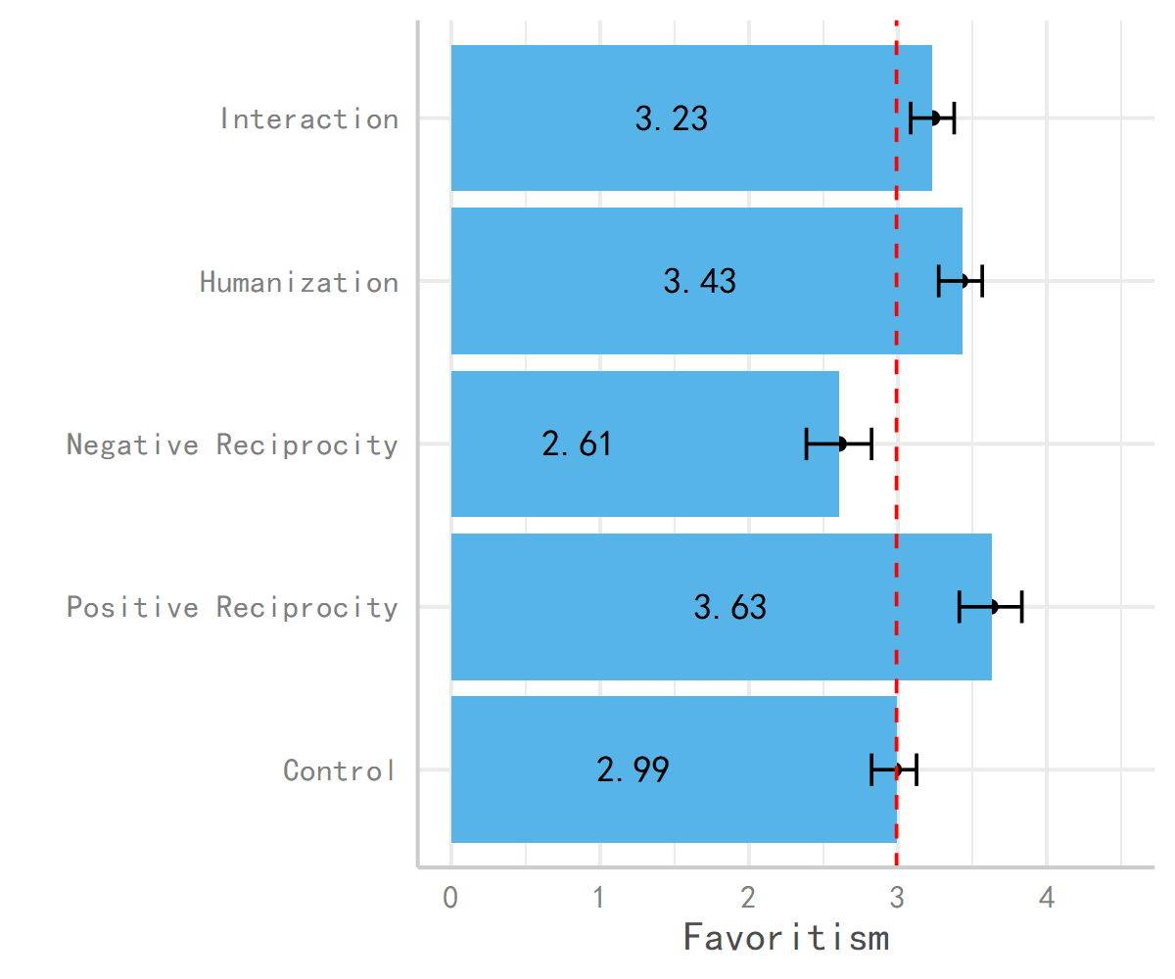
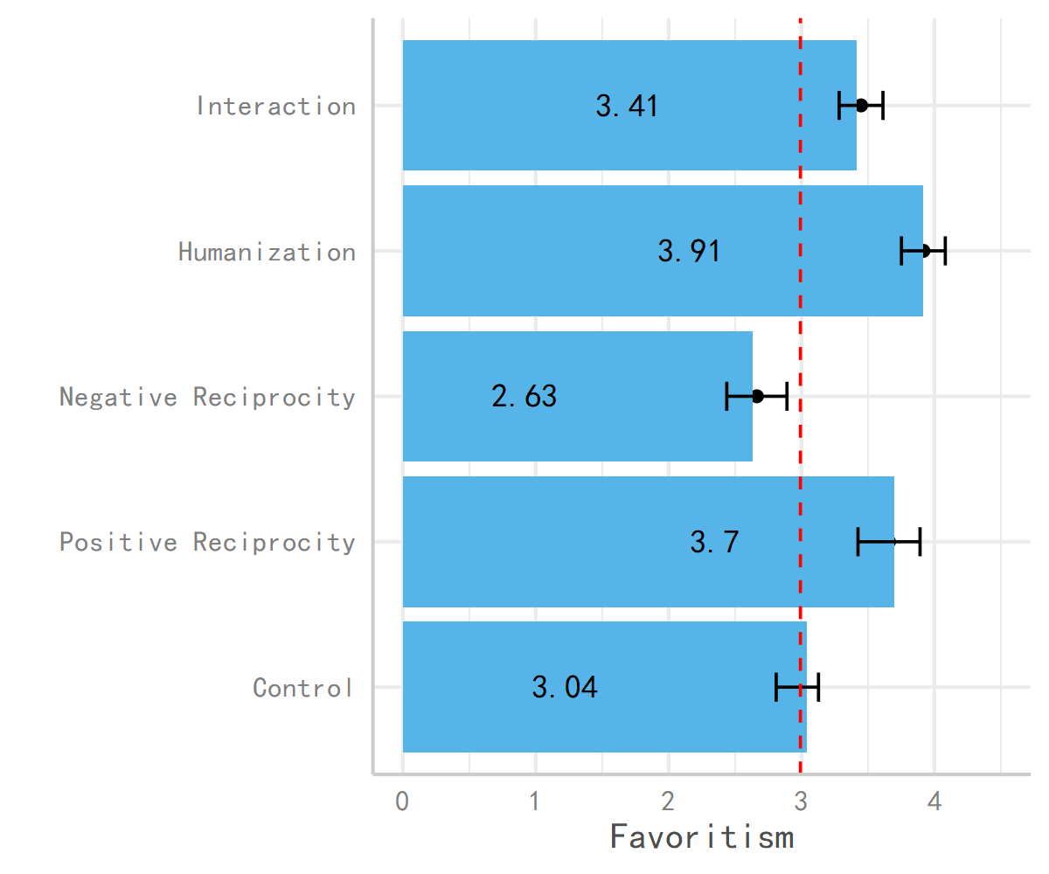
However, something surprising occurred as we provided more and more humanizing treatments to our research subjects. Respondents who were told they had a partner (the interaction group) and were given humanizing details about that partner (the humanization treatment) in both countries reported more favorable views of one another. Even something as simple as knowing their partner in another country liked chocolate ice cream was enough to induce more favorable opinions about the other country.
Interestingly, we can see similar effects when we ‘revealed’ the respondent’s partner’s positive or negative responses as well. When a person heard that their partner had a favorable view of their country, their views became more favorable as well, showing a certain reciprocity at play. Likewise, when they heard their partner had a negative view, they responded even more harshly, evaluating the other country far more negatively.
Overall, the implications for this study are numerous. On the optimistic side, it shows the value of encouraging person-to-person contacts between these two countries to moderate negative views and encourage productive relations. It tells us that simply viewing another country as being made up of real human beings has powerful effects on national sentiment. More pessimistically, it also shows some potential negative spillover effects of aggressive, wolf-warrior style diplomacy pursued by Beijing and similar aggressive policies from Washington. When individuals feel their country is viewed negatively, they respond aggressively in kind, and hostile diplomatic tactics by both Beijing and Washington may only breed more resentment abroad.

